A model to embed clinical simulation training during normal ambulance shift work

Abstract
Paramedic education is now commonly delivered by educational institutions but there is still a continuous need to ensure the competency of experienced staff and to help with orientation to newly adopted pieces of equipment, brief staff concerning new protocols or guidelines, and to allow them to practise in a safe and controlled environment. A complementary solution to traditional training rooms propose in this paper is to use a mobile simulation unit to take the training where ambulance staff are located to fulfil their duty of care. The possibility of offering simulation training using a specially designed vehicle while a crew is waiting would improve the efficiency of the use of their time and enhance their training opportunities. There are several options regarding the training vehicle that could be used to fulfil this role depending on the budget and facilities that are to be offered during the training, but only two will be explored in this paper. An additional key resource that will be discussed is the team of educators that are required to facilitate such training sessions to ensure they are effective and valuable learning experiences that will enhance pre-hospital care service delivery and benefit patient care. Over time, the training vehicle and its team, supported by an additional ambulance to cover for the team undertaking the training, would conduct their focused simulation training sessions with all the clinical staff of an ambulance service without affecting the rota of the crews or putting temporarily geographical areas at risk. The seeming strengthening link between enhanced levels of patient safety and the use of clinical simulation, while still not fully evidenced, is becoming more established especially as ways of integrating such activities with day-to-day operations can be developed and adopted.

Keyword: education model, mobile training, ambulance, in-situ simulation, paramedic.

Background

Simulation has been a core educational component of paramedic, ambulance technicians, Emergency Care Support Worker (ECSW) training, education and continuing professional development for several decades, especially for the practice and acquisition of life support skills (Gordon, Issenberg, Mayer, & Felner, 1999; Hall et al., 2005; Stratton et al., 1991). Such training and educational interventions are however fairly rare in frequency and often quite limited in terms of scope and realism, as they often lack the element of surprise for the participants and do not necessarily allow them to exercise or demonstrate their critical thinking skills. Upon qualification, and having mastered all the clinical skills linked to the profession, simulation can still play a very important role in ensuring continued competency and the continued readiness of pre-hospital care team members to respond to various types of incidents.

It can also help facilitate familiarisation with new techniques and items of equipment, while also playing an important role in ensuring that clinicians can demonstrate the effective integration of both clinical and non-technical ‘human factor/crew resource management skills that is so important in providing effective care to the ill or injured, individually or as part of a wider team (Alinier, 2009; Newton, Benn, & Rhodes, 2001). The absence of the latter is a key factor accounting for numerous preventable deaths every year caused by healthcare systems worldwide (Kohn, Corrigan, & Donalson, 1999). Although errors occurring in Ambulance Services and international pre-hospital and out of hospital services have not been as widely studied as those occurring in hospital setting and where data exists it is often drawn from international examples, there does appear to be a growing body of literature indicating that some themes are emerging. St Pierre et al. (2008) has suggested two particular areas of concern with ‘on-scene performance’ including patient assessment and drug related errors. Arntz et al. (1996) identified patient assessment concern, as has Kothari et al. (1995), while Brice (2008) has focused on shortcomings in documentation.

Williams (2007) found that English Courts tended to take a relatively lenient view when considering the actions of emergency services. However, patient safety continues to move up the political and NHS agenda and the recent Francis report (House of Commons, 2013) is likely to both accelerate actions to increase this focus and indeed the work of Don Berwick, the well known researcher in patient safety has now attracted the attention of ‘number 10’ and David Cameron (Kline, 2013). Clinical simulation is therefore one increasingly acknowledged strategy that can help provide counter measures to sub-standard clinical practice, while also militating in favour of moving all clinicians towards the goal of delivering the best practice standards of care.

In the UK the proportion of paramedics graduating from University-based programmes continues to rise (Fayers & Bates, 2011), with the number of BSc and Foundation Degrees approved by the Health and Care Professions Council (HCPC) and the College of Paramedics increasing rapidly (HPC - Health Professions Council, 2013). It is however, still customary for Ambulance Services to have a training and education department with simulation equipment such as more or less advanced patient simulators and part-task trainers (Alinier, 2007, 2010). Such facilities are used for intensive training courses for new recruits, typically at the ECSW grade or for newly registered paramedics joining directly from University or for those taking ‘in service programmes’ that lead to paramedic registration, typically Foundation Degrees, offered in partnership with Higher Education Institutions.

There is also a continuing need to ensure the competency of experienced staff and to help with orientation to newly adopted pieces of equipment or to brief staff concerning new protocols or guidelines and allow these clinicians to practise in a safe and controlled environment. In nearly all instances these activities require ambulance personnel to be ‘abstracted’ from scheduled duties and taken “off the road” at significant cost, and to come to the training facility to take part in the training activity. Such hindrances impacts on the effectiveness of an Ambulance Service to serve the public and limits the training opportunities, especially for qualified staff. A complementary solution is to develop a mobile simulation unit to take the training to where ambulance staff are located to fulfil their duty of care. A similar approach has already been developed in the form of a clinical skills bus moving from hospital to hospital while nursing and medical students are on placement (Nicol, Warren, & Connolly, 2007). Such a vehicle has also been developed to serve the needs of staff employed in Hazardous Area Response Teams (HART) as illustrated in Figure 1.

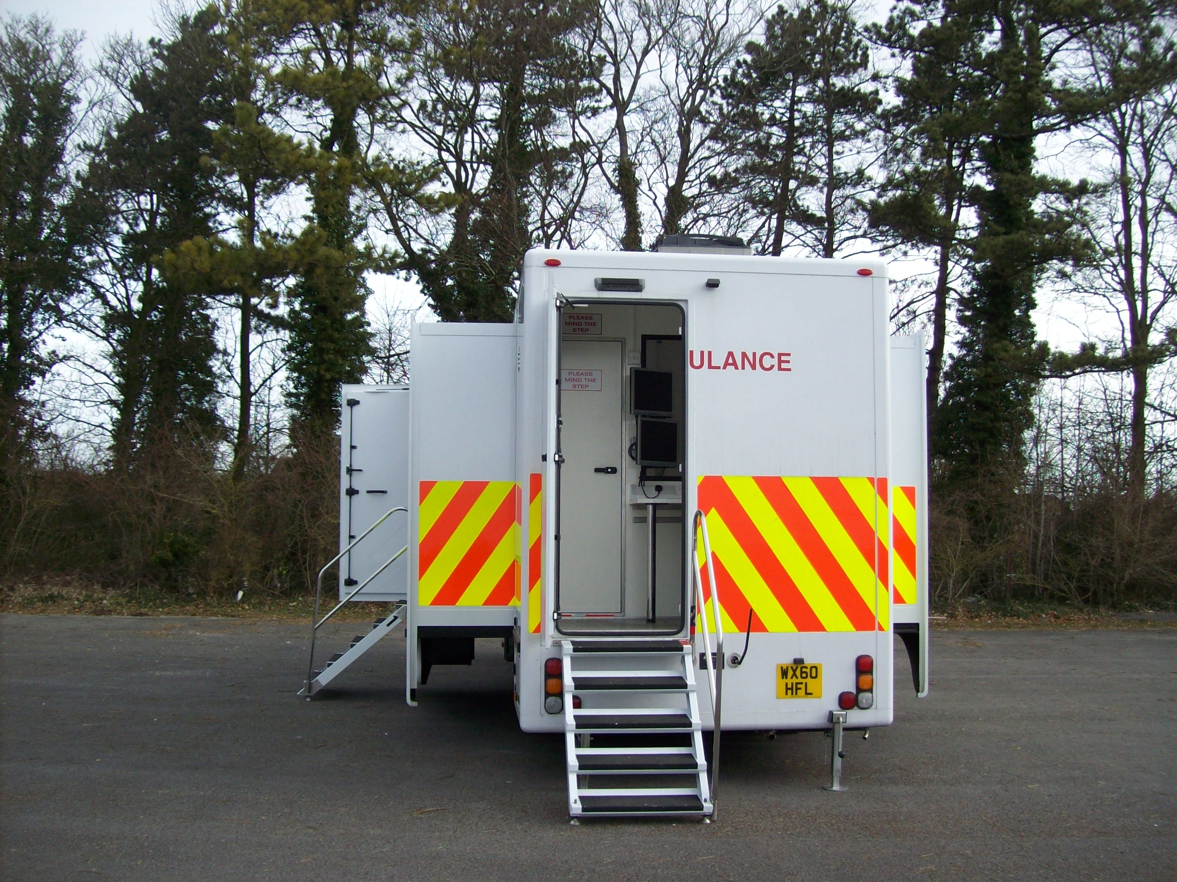
Figure 1: Hazardous Area Response Teams training ambulance from the West Midlands Ambulance Service NHS Trust (Picture courtesy of Mr Dave Bull and Mr John Hopkins of the National Ambulance Resilience Unit UK ...).

Simulation training at the roadside

Providing simulation training at the roadside for ambulance staff is equivalent to facilitating “in-situ” simulation for hospital staff. In-situ simulation is to be understood as providing simulation-based education in the real setting rather than in simulated environment. It is fairly common practice in hospitals either because it is proving more economical than building a dedicated training facility or because it is judged to be the most appropriate setting to provide training as it is more realistic, however, it also presents disadvantages (Patterson, Blike, & Nadkarni, 2008). Commonly cited drawbacks of doing hospital-based in-situ simulation include: interruptions to deal with emergencies, risk of mixing patient use and educational resources (equipment, training drugs), space temporarily not usable for real patient care, infection control, noise, potential issues with permission to video record the learning event, time to setup the venue (patient simulator and audio-visual equipment), and causing anxiety to real patients who may see the commotion potentially created by the simulated event. Measures do exist to prevent some of these limitations, but they are always omnipresent.

A number of these drawbacks do not exist in the pre-hospital care setting or are more easily addressed. In addition to being located at ambulance stations it is usual for ambulances to be on standby in various key locations as per instructions from their dispatch centres. This is done to ensure low response times to emergency calls in areas where there is no ambulance station (Stout, 1983) but also means that crews can be idle for a while simply waiting to be dispatched. The possibility to offer simulation training in this way while a crew is waiting would improve the use of their time and enhance their training opportunities. The proposed model consists of taking the training to the crew at the roadside in the form of a purposely equipped training vehicle with trained paramedic educator accompanied by another crew and their ambulance to cover for the crew undertaking the simulation activity. Should the ambulance need to be dispatched, the training would not be interrupted, as the accompanying crew would act as the substitute ambulance response team. However, in extremis the training crew, of which there might be several in a larger Ambulance Service, could also respond, albeit with a slight delay, thereby providing a ‘surge’ capability in instances of intense, but unexpected spikes in demand.

The training vehicle

There are several options regarding the training vehicle that could be used to fulfil this role depending on the budget and facilities that are to be offered during the training, but only two will be explored in this paper. Both options allow for re-enactment of outdoor scenarios if required if it more appropriate to address the learning objectives.

The first option is to adapt a standard ambulance, fully equipped, with cameras and microphones to record the scenarios, and some form of display device with audio to offer the opportunity to deliver any teaching material and play back some video footage of the simulation experience if required. Although this may appear to be optional equipment, it can greatly enhance the educational experience and has become a core component of most simulation related training activities to record and review scenarios, and to allow remote observation by peers or assessors (Alinier, 2009). That adapted training ambulance would also be used to transport the patient simulator and any props that may be required during the scenarios.

The second option would be to outfit a larger van or trailer to simulate the room of a house or apartment where ambulance staff are often required to make the primary assessment of a patient, such as a living room, a bedroom, or a bathroom. That van would also be used to transport the patient simulator and any props that may be required during the scenarios and would need to be equipped with a similar camera system with microphones and some form of display device with audio. In this instance the crew taking part in the scenario may need to transfer the patient from this customised training van or an outdoor context to their own ambulance and use their own supplies and equipment. Any used disposable equipment, sterilised devices, or drugs would be replaced with stock from the training van.

In both instances, the audio-visual (AV) system, preferably with controllable pan/tilt/zoom cameras, would need to be complemented by a mobile system equally advanced and integrated onto the same software platform for the seamless transfer of the patient and the physiological data from its original environment to either the adapted training ambulance or the ambulance from the crew undergoing the training. Integrated wireless and battery powered high quality camera and data capture systems allow for the easy integration of such mobile recording systems to a central high capacity networked video recorder.

The team facilitating the simulation training

Although some forms of simulation have always been used by ambulance services for training, the type of simulation recommended in this model requires special knowledge of high-fidelity simulation education and debriefing on the part of the educators (Alinier, 2009; Issenberg, 2006). There are many aspects to running a simulation session that call upon a range of skills (Lambton & Prion, 2009) that need to be acquired through training and guided experience, hence simulation sessions and scenarios are usually facilitated by a team comprising at least an operator or technician and a clinician (Alinier, 2011; Gantt, 2012).

The clinical skills, knowledge, and credibility of the simulation educators are central to the success of the exercise, with a requirement to modify and flex the simulation experience to the learning needs and styles of the participants. Crew engagement is likely to be greater if the educator can draw upon real world case studies, possibly generated from a contemporary ‘adverse incident’ or complaints database that has been subject to a detailed incident review process and coupled with the identification of themes emerging from a consequent learning needs analysis. The crew taking part in the scenarios should not feel unduly under pressure by the simulation educators, but the atmosphere should not either be so collegial that the activity is not taken seriously.

The educators need to adopt the right attitude to positively engage the learners without discouraging them should they not perform satisfactorily during the scenario(s). Beside the hands-off aspect of facilitating a scenario on the part of the simulation educators, the debriefing is often considered the most difficult aspect of running a simulation session as it is often confused with feedback. The process of debriefing has been described by Petranek et al. (1992) as “an oral discussion session in which students and teachers engage in a question and answer session designed to guide students through a reflective process about their learning” (p.176). A key role of the debriefing facilitator is to identify and close gaps in the knowledge and skills of the learners (Raemer et al., 2011). A good debriefing helps learners understand every aspects of the events of a scenario and the effect of their actions on the direction it took.

Another important aspect is the technical ability of at least one member of the simulation education team to setup the patient simulator and AV equipment and troubleshoot any potential technical issue at the roadside. Being very familiar with the connectivity, software, and hardware, of all simulation equipment with the computer(s) or between themselves is a must and is a clear advantage to think of work around solutions should a problem arise during a session so the learning is not affected or even totally interrupted.

The roadside training session

In the model presented in this paper, the training team would be expected to facilitate approximately three sessions of two hours per day as travelling time should be accounted for between the locations of the ambulances. Over time, the training vehicle and its team, supported by an additional ambulance to cover for the team undertaking the training, would conduct their focused simulation sessions with all the clinical staff of an ambulance service without affecting the rota of the crews or putting temporarily geographical areas at risk. As an example, Table 1 presents the typical breakdown of time of such a session for the simulation education team and the crew taking part in the training activity.

Several approaches can be adopted with regards to initiating a roadside training session. Either the training team drives to the location of an ambulance on standby having contacted its crew with only a few minutes of notice to warn them of the training session, either the crew is dispatched as if it was responding to a real incident to actually meet the training vehicle at a nearby location (literally at the corner of the street or other suitable public area they, in order that they do not have to drive with lights and sirens). The latter would be more realistic and provides time for the training team to setup everything required for the session such as positioning the mobile AV system and patient simulator or standardised patient (briefed actor) outside prior to the arrival of the ambulance crew.

Ideally no orientation period should be required as the crew members would be operating in their normal environment, a place they do not need to be familiar with (outside on the pavement o inside someone’s house, i.e. the customised vehicle) or an ambulance (theirs or one very slightly modified), and they should already be used to interacting with patient simulators and standardised patients. Having been briefed over the radio about the simulated incident and possibly gaining information from a member of the training team acting as a bystanders, there would be no need for the ambulance crew to interact with the educators in that capacity before the end of the scenario, but only at the time of the debriefing. As illustrated in Table 1, following the debriefing, time could be allocated to address identified learning or skills deficiencies, or reviewing important learning points. Time could also be usefully spent discussing broader or very specific themes identified by the quality or clinical department. This could be disseminated and discussed as additional learning points in view of improving other aspects of the service (Generic learning session).

The session should end with an evaluation of the learning experience. This could be done online immediately, at the end of the shift, or within a short timeframe after the session. A system should also be put in place to encourage staff to further reflect on that simulation experience and write a reflective account of the event in their professional portfolio (Jones & Cookson, 2000) within a couple of days of having taken part in the scenario as evidence of additional professional development.

15 min | 20 min | 30 min | 20 min | 20 min | 5 min | 10 min
Setup | Scenario | Debriefing | Addressing identified deficiencies or reviewing important points | Generic learning session | Session evaluation | Set down, ready to drive to next location.
Dispatch call made to nearby ambulance crew | Ambulance crew undergoing training |  |  |  |  | Ambulance regains original position
Second ambulance and its crew covers the crew taking part in the training activity

Table 1: Example of the breakdown of time during a road-side simulation session.

Discussion
Improving the quality of health care and making harm to patients less likely is moving ever higher in the minds of political leaders and heath policy makers. The seeming strengthening link between enhanced levels of patient safety and the use of clinical simulation, while still not fully evidenced, is becoming more established. This form of training is therefore increasingly relevant and valuable in counter acting clinical errors and militating in favour of attaining best practice. The work of Wyatt et al. (2004) that demonstrates a favourable relationship and a reduction of errors associated with paramedics managing simulated patients suffering traumatic injuries also shows that clinical simulation for the paramedic community is becoming more mainstream and ever more useful. Wyatt’s work involved student paramedics, but other researchers such as Rortgen et al. (2013) have shown that clinical simulations, employing paramedics and physicians, found that both groups where able to demonstrate comparable levels of clinical performance.

At a time when money is in short supply and with demand for emergency and urgent health care increasing rapidly, finding methods to help staff retain high levels of technical competency and doing so at the lowest possible costs is more necessary then ever. The use of a mobile simulation vehicle can therefore potentially offer a useful development that is likely to be well received by staff.

Relatively detailed advice on the development of such training unit within an ambulance service has already been provided (Alinier, 2010) but this paper concentrates on a model particularly suited to operational staff while on field duty. It is not yet a commonly applied technique and while a number of initiatives have been developed internationally, there are few if any examples where a shift to full-scale and fully integrated mobile simulation has been achieved in a large Ambulance Service. The predominant use of clinical simulation therefore continues to occur in the initial training and education phase of paramedic and ambulance clinician careers, thereby creating an opportunity for the further development and wider application of these methods. In order to test the viability and cost-effectiveness of this approach large studies are required to determine the feasibility and effect, but given the central place that clinical simulation has gained in the educational process there is reason to be optimistic that wider application to the post-qualification phase may well prove to be of value.

Conclusion

Raising the standards of clinical quality in Ambulance Services, while also concurrently improving staff satisfaction through relevant focused training experiences and achieving this at reasonable cost, is something akin to seeking out the Holy Grail. Many attempts to maintain standard of clinical competency through on-going classroom based ‘annual key skills’ or similar approaches often fail to capture the imagination of Paramedics and other ambulance clinicians, while also proving to be expensive in terms of staff abstraction from their primary duties and therefore risk being relatively ineffective and costly. More imaginative solutions are required that draw on clinical simulation, accentuating staff engagement, achieving these aim without undue or expensive disruption to the primary service function.

The use of mobile simulation, closely integrated with day-to-day Ambulance Service operations represents one potential accessible option that is now increasingly available and which addresses the timeless problem of maintaining clinical and non-technical skills in the workplace. An added advantage can be gained if the scenarios utilised are drawn from recent adverse incidents and well founded complaints, thereby holding out the prospect of translating ‘lesson learned’ into changes in clinical practice that respond directly to improved patient safety.

If such arrangements can be routinely scheduled throughout the full working week and offered on the basis of very short notice to ambulance crews they are more likely to more accurately reflect actual levels of competence and the stresses involved in delivery of pre-hospital and out of hospital patient care. The approach described is also more likely to create higher levels of realism that reflect real world of paramedic and ambulance clinician practice, while more truly mirroring the actual working environment in which clinical practice takes place.

Prof Guillaume Alinier
Associate Editor IPP
Professor of Simulation in Healthcare Education, University of Hertfordshire, UK

Prof Andy Newton
Executive Paramedic Director – South East Coast Ambulance Service NHS Trust
Consultant Paramedic, Visiting Professor at the University of Surrey, Council Chair of the College of Paramedics

References:

