**Are General Practice based pharmacists guardian angels for antibiotic prescribing in primary care? A quality improvement project using a point prevalence analysis of antimicrobial prescribing rates across 122 General Practice surgeries in England**

**INTRODUCTION**

Antimicrobial resistance (AMR) is recognised as a worldwide public health problem with the negative impact on health and economic outcomes well established [1] [2] [3]. An important driver of resistance is the medical use, misuse and overuse of antibiotics [4]. Antimicrobial stewardship (AMS) programmes are intended to counter this by optimizing antibiotic use to improve patient outcomes while at the same time minimizing toxicity and other adverse events.

With primary care accounting for over 80% of all antibiotics prescribed in England [5] this setting is a natural target for significant AMS efforts. In 2015, NHS England (NHSE) published the antibiotic Quality Premium to financial reward Clinical Commissioning Groups (CCGs) (who are responsible for commissioning healthcare for a local population) to reduce the number of antibiotics prescribed in general practice by 1% (or greater) per year [6] [7] . The 2018 ESPAUR report showed that between 2013 and 2017, overall antibiotic prescribing in primary care fell by 13.4% in general practice [5].

Despite these reductions, the UK 5-year action plan for AMR published in 2019 has set a target to reduce UK antimicrobial use in humans by 15% by 2024 [8]. The workforce shortfall in primary care in England will be a challenge to this ambition. NHSE has set out how changing the skill mix is one way that it intends to address the shortfall. Under the new five-year GP contract, clinical pharmacists are to be central to this change with a typical Primary Care Network (PCN) of 50,000 patients expected to have up to five clinical pharmacists by 2024, the equivalent of one pharmacist per GP practice [9].

In 2016, the government committed over £100 million to support an extra 1,500 clinical pharmacists to work in general practice by 2020 [10]. Consequently, in line with the phased increase in investment, clinical pharmacists are working in these relatively new and developing roles with ever growing numbers. As of December 2018, 29 of the 122 practices across the 2 CCGs in Hertfordshire have a clinical pharmacist assigned to their practice many as independent non-medical prescribers. The objectives of the analysis were to compare antibiotic prescribing rates in those practices with a clinical pharmacist to those without.

**METHODS**

This cross‐sectional retrospective point prevalence survey utilized data from the NHS Digital (NHSBSA) database. In line with the 2018/19 iteration of the quality premium, antibiotic prescribing rates from all GP practices across Hertfordshire for December 2018 were analysed [11]. These data are corrected for population structure by including the number of antibacterial items per STAR-PU (Specific Therapeutic group Age-sex Related Prescribing Units), an age and sex weighted prescribing unit based on GP registered population. T-tests were used to test for a difference between the CCGs, HV and ENH individually and then combined, after checking the appropriate statistical assumptions were met.

**RESULTS**

Data from all 122 practices across the 2 CCGs in Hertfordshire were collected. Fifty-five practices from East and North Hertfordshire CCG (ENHCCH) 67 from Herts Valleys CCG (HVCCG). Seventeen (31%) of the 55 practices in ENHCCG have a clinical pharmacist and 12 (18%) of the HVCCG practices have a clinical pharmacist.

|  |  |  |  |  |  |  |  |  |
| --- | --- | --- | --- | --- | --- | --- | --- | --- |
|  | **With CP** | | **Without CP** | | **Items Difference** | ***95% CI*** | **p-value** | **Power** |
|  | **Items** | **N** | **Items** | **N** |
| ENHCCG | 0.943 | 17 | 0.964 | 38 | 0.021 | *(-0.06, 0.10)* | 0.584 | 0.085 |
| HVCCG | 0.869 | 12 | 0.942 | 55 | 0.073 | (-0.03, 0.17) | 0.145 | 0.303 |
| Hertfordshire | 0.912 | 29 | 0.951 | 93 | 0.039 | (-0.02, 0.10) | 0.214 | 0.236 |

**Table 1: Average antibiotic prescribing rates in East and North Herts CCG (ENHCCG), Herts Valleys CCG (HVCCG) and both CCGs combined divided into those practices with a clinical pharmacist (CP) and those without a CP.**

Across the two CCGs, average prescribing rates are 4.3% lower in those practices with a clinical pharmacist than those without, with a difference of 0.039 items per STAR-PU (p=0.214). The small number of practices with CPs combined with the small absolute difference in items meant that the statistical power of the test was low, at around 24%.

There was no evidence that either HV or ENH displayed differences in the number of items per STAR-PU, with p=0.145 and p=0.584 respectively. However, the data indicates a possible larger difference for HV, but a larger sample is required to confirm the magnitude of the observed differences. The confidence interval for the differences, along with the powers of the tests, indicate that the results need to be interpreted with caution until larger samples can be gathered.

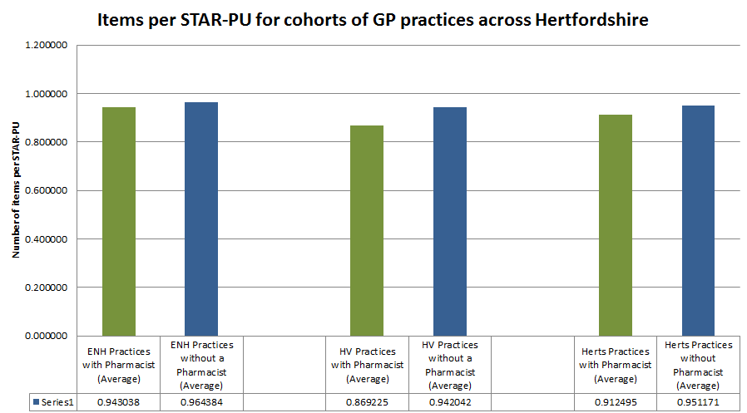

**Graph 1: Average antibiotic prescribing rates in East and North Herts CCG (ENHCCG), Herts Valleys CCG (HVCCG) and both CCGs combined divided into those practices with a clinical pharmacist (CP) and those without a CP.**

**DISCUSSION**

The number of non-medical prescribers (NMPs) in England, who have independent prescribing capability, has risen by over one-third to nearly 30000 between 2011 and 2016. The rate of dispensed NMP prescriptions for antibiotics over this period has increased, as has the percentage of all primary care antibiotics dispensed that were prescribed by NMPs, which is currently nearly 8% [12]. During this period the proportion of pharmacists that formed the NMPs rose from 6.9% to 9.9%. Funding from the new five-year GP contract means these NMP numbers will expand rapidly in the next few years. An estimated 20,000+ additional posts in five specific different primary care roles are to be created in England in the five years from 2019 to 2024. These five roles are clinical pharmacists, social prescribing link workers, physician associates, first contact physiotherapists and first contact community paramedics, many will have prescribing capability.

The distribution of the new workforce across the five roles will depend on the choices that individual networks make. However NHSE has indicated that by 2024, a typical PCN will have 5 clinical pharmacists, the equivalent of one pharmacist per GP practice [9]. With over 7,000 GP practices in England, this would represent a dramatic uplift from 491 GP practice pharmacists in February 2019 reported by NHSE [13]. Despite this there is a paucity of evidence to support the role of clinical pharmacists integrated into the GP practice team. This is currently an ill-defined role but one that by necessity will be distinct from that of the community and hospital clinical pharmacy [13].

Antimicrobial pharmacists in hospital are seen as a key enablers to the delivery of AMS in secondary care [14] [15] [16] [17]. Here they affect antimicrobial stewardship beyond that of their own personal prescribing practice [18]. This pharmacists role as a ‘prescribing influencer’ should be exploited in primary care, where more than 80% of antibiotics are prescribed, as UK strives to achieve the target to reduce antimicrobial use in humans by 15% by 2024.

This paper is the first to our knowledge to present data on antibiotic prescribing in general practice with a specific focus on clinical pharmacists based in General Practice in England. Our analysis shows average lower prescribing rates in those practices with a clinical pharmacist than those without. The importance of NMP prescribing and the effect of clinical pharmacists on antimicrobial stewardship will continue to grow over the coming years as the nature of the workforce changes in the coming years. With the new five-year GP contract calling for an enhanced role for pharmacists in primary care it is clear, as the NHS Chief Pharmaceutical Officer points out, these pharmacists will be increasingly vital to the delivery of AMS across primary care teams in future [19]. Specifically tailored educational initiatives and continued professional development are therefore required ensure the unique skills of these pharmacists can be optimised to further AMS across primary care [20].

# Works Cited

|  |  |
| --- | --- |
| [1] | G. M. Eliopoulos, S. E. Cosgrove and Y. Carmeli, "The Impact of Antimicrobial Resistance on Health and Economic Outcomes," *Clinical Infectious Diseases,* vol. 36, no. 11, pp. 1433-1437, 1 6 2003. |
| [2] | S. E. Cosgrove, "The Relationship between Antimicrobial Resistance and Patient Outcomes: Mortality, Length of Hospital Stay, and Health Care Costs," *Clinical Infectious Diseases,* vol. 42, no. Supplement_2, pp. S82-S89, 16 12 2005. |
| [3] | R. D. Smith and J. Coast, "Antimicrobial resistance: a global response," *Bulletin of the World Health Organization,* vol. 80, pp. 126-133, 2002. |
| [4] | A. Sundsfjord and M. Steinbakk, "Article in The Lancet ·," 2015. |
| [5] | "English Surveillance Programme for Antimicrobial Utilisation and Resistance (ESPAUR)," 2018. |
| [6] | "Quality Premium: 2015/16 guidance for CCGs". |
| [7] | A. P. Johnson, D. Ashiru-Oredope and E. Beech, "Antibiotic Stewardship Initiatives as Part of the UK 5-Year Antimicrobial Resistance Strategy.," *Antibiotics (Basel, Switzerland),* vol. 4, no. 4, pp. 467-79, 30 10 2015. |
| [8] | "The UK's five-year national action plan," 2019. |
| [9] | "Investment and evolution: A five-year framework for GP contract reform to implement The NHS Long Term Plan," 2019. |
| [10] | "GENERAL PRACTICE FORWARD VIEW," 2016. |
| [11] | "Technical Guidance Annex B Information on Quality Premium". |
| [12] | M. Courtenay, D. Gillespie and R. Lim, "Patterns of dispensed non-medical prescriber prescriptions for antibiotics in primary care across England: a retrospective analysis," *Journal of Antimicrobial Chemotherapy,* vol. 72, no. 10, pp. 2915-2920, 1 10 2017. |
| [13] | C. Mann, C. Anderson, A. J. Avery, J. Waring and M. J. Boyd, "Clinical Pharmacists in General Practice: Pilot scheme Independent Evaluation Report: Full Report National Evaluation of Clinical Pharmacists in GP Practices (Pilot Phase) | 1," 2018. |
| [14] | H. J. Wickens, S. Farrell, D. A. Ashiru-Oredope, A. Jacklin and A. Holmes, "The increasing role of pharmacists in antimicrobial stewardship in english hospitals," *Journal of Antimicrobial Chemotherapy,* vol. 68, no. 11, pp. 2675-2681, 11 2013. |
| [15] | K. Hand, "Antibiotic pharmacists in the ascendancy," *Journal of Antimicrobial Chemotherapy,* vol. 60, no. SUPPL. 1, 8 2007. |
| [16] | M. Gilchrist, P. Wade, D. Ashiru-Oredope, P. Howard, J. Sneddon, L. Whitney and H. Wickens, "Antimicrobial Stewardship from Policy to Practice: Experiences from UK Antimicrobial Pharmacists," *Infectious Diseases and Therapy,* vol. 4, no. S1, pp. 51-64, 11 9 2015. |
| [17] | "Pharmacy’s role in antimicrobial resistance and stewardship," *Clinical Pharmacist,* 2018. |
| [18] | "Behaviour change and antibiotic prescribing in healthcare settings Literature review and behavioural analysis," 2015. |
| [19] | "NHS England » Clinical pharmacists vital to patient care in five-year GP deal," [Online]. Available: https://www.england.nhs.uk/2019/01/clinical-pharmacists-vital-to-patient-care-in-five-year-gp-deal/. |
| [20] | E. Castro-Sánchez, L. N. Drumright, M. Gharbi, S. Farrell and A. H. Holmes, "Mapping Antimicrobial Stewardship in Undergraduate Medical, Dental, Pharmacy, Nursing and Veterinary Education in the United Kingdom," *PLOS ONE,* vol. 11, no. 2, p. e0150056, 29 2 2016. |