Role of RhoB in the regulation of pulmonary endothelial and smooth muscle cell responses to hypoxia.

Beata Wojciak-Stothard, PhD†; Lan Zhao PhD†, Eduardo Oliver, PhD†; Olivier Dubois†, Yixing Wu, MSc†, Dimitris Kardassis, PhD‡, Eleftheria Vasilaki, PhD‡; Minzhou Huang, PhD§ Jane A. Mitchell, PhD††, Harrington Louise, PhD ††, George C. Prendergast, PhD§§, Martin R. Wilkins M.D†

†Centre for Pharmacology and Therapeutics, Experimental Medicine, Imperial College London, London, UK; ‡ University of Crete Medical School, Heraklion, Greece; § Ludwig Institute of Cancer Research, Uppsala, Sweden; ††Cardiothoracic Pharmacology, NHLI, Imperial College; Dovehouse Street, London SW3 6LY, UK; §§ Lankenau Institute for Medical Research, Wynnewood PA , USA

Short title: RhoB in pulmonary vascular responses to hypoxia

Name and address for correspondence:

Dr Beata Wojciak-Stothard,
Centre for Pharmacology and Therapeutics,
Department of Medicine, Imperial College London,
Du Cane Road, London W12 0NN, UK

Email: b.wojciak-stothard@imperial.ac.uk

Tel: +44 (0)02075946821
Fax: +44(0)2075946815

Total word count: 6,929

Subject Codes:
[18] Pulmonary circulation and disease
[97] Other Vascular biology
[115] Remodelling
[138] Cell signaling/signal transduction
[130] Animal models of human disease
[137] cell biology/structural biology

ABSTRACT.

Rationale: RhoA and Rho kinase contribute to pulmonary vasoconstriction and vascular remodelling in pulmonary hypertension. RhoB, a protein homologous to RhoA and activated by hypoxia, regulates neoplastic growth and vasoconstriction but its role in the regulation of pulmonary vascular function is not known.

Objective: To determine the role of RhoB in pulmonary endothelial and smooth muscle cell responses to hypoxia and in pulmonary vascular remodelling in chronic hypoxia-induced pulmonary hypertension.

Methods and results. Hypoxia increased expression and activity of RhoB in human pulmonary artery endothelial and smooth muscle cells, co-incidental with activation of RhoA. Hypoxia or adenoviral overexpression of constitutively activated RhoB increased actomyosin contractility, induced endothelial permeability and promoted cell growth; dominant negative RhoB or manumycin, a farnesyltransferase inhibitor that targets the vascular function of RhoB, inhibited the effects of hypoxia. Coordinated activation of RhoA and RhoB maximized the hypoxia-induced stress fibre formation caused by RhoB/mDia-induced actin polymerisation and RhoA/Rho kinase-induced phosphorylation of myosin light chain on Ser19. Notably, RhoB was specifically required for hypoxia-induced HIF-1α stabilization and for hypoxia- and PDGF-induced cell proliferation and migration. RhoB deficiency in mice markedly attenuated development of chronic hypoxia-induced pulmonary hypertension, despite compensatory expression of RhoA in the lung.

Conclusions: RhoB mediates adaptational changes to acute hypoxia in the vasculature, but its continual activation by chronic hypoxia can accentuate vascular remodelling to promote development of pulmonary hypertension. RhoB is a potential target for novel approaches (eg farnesyltransferase inhibitors) aimed at regulating pulmonary vascular tone and structure.

Key words: Hypoxia, Pulmonary hypertension, Rho GTPases, endothelium, smooth muscle cells

Non-standard Abbreviations and Acronyms:
BMP: bone morphogenetic protein; BMPR2: BMP receptor type 2; GTPase: guanosine triphosphatase; HIF: hypoxia inducible factor; HPAEC: human pulmonary arterial endothelial cell; HPASMCs: human pulmonary artery smooth muscle cells; PAH: pulmonary arterial hypertension; TGF-β: transforming growth factor-β; NFκB: nuclear factor kappa B; VEGF: vascular endothelial growth factor; PDGF: platelet derived growth factor; FGF: fibroblast growth factor; EGF: epidermal growth factor; PKA: protein kinase A; PKG: protein kinase G; MTS: [3-(4,5-dimethylthiazol-2-yl)-5-(3-carboxymethoxyphenyl)-2-(4-sulfophenyl)-2H-tetrazolium; U2OS-HRE-luc: human osteosarcoma cells stably expressing a luciferase reporter construct under the control of a hypoxia response element; MLC: myosin light chain; mDia: mammalian homolog of Drosophila diaphanous; VE-cadherin: vascular endothelial cadherin; PCNA: proliferating cell nuclear antigen; RVSP: right ventricular systolic pressure; CARhoB: constitutively activated (V14) RhoB; DNRhoB: dominant negative (N19)RhoB

Introduction.

Chronic hypoxia-induced pulmonary hypertension is characterised by increased right ventricular afterload from increased pulmonary vascular resistance due to pulmonary vasoconstriction and pulmonary vascular remodelling¹. Hypoxic pulmonary vasoconstriction (HPV) helps to maintain oxygen supply within physiological limits by diverting blood from poorly-ventilated to better ventilated areas of the lung². Activation of RhoA/Rho kinase in pulmonary vasculature contributes to sustained HPV and pulmonary vascular remodelling in hypoxia-induced pulmonary hypertension and in other forms of pulmonary hypertension^{3,4}. RhoA is a member of the Rho GTPases family of proteins, key regulators of actin-dependent processes such as cell adhesion, migration and proliferation⁵. In the vascular wall, activation of RhoA and Rho kinase increases SMC contractility, increases endothelial permeability, and inhibits NO generation by decreasing endothelial nitric oxide synthase (eNOS) expression and activity⁶⁻⁸. Inhibition of the RhoA/Rho kinase pathway contributes to the beneficial effects of sildenafil in PH but statins, another inhibitor of this pathway, have little effect on the course of human pulmonary hypertension⁹⁻¹¹.

Recent data implicate RhoB, a protein 85% homologous to RhoA and highly expressed in the lung¹², in cell responses to oxidative stress. RhoB is activated by hypoxia^{13,14} and genotoxic stress¹⁵. Protein levels are turned over more rapidly than other Rho GTPases (120 minutes versus 24 hours, respectively)¹⁶. RhoA and RhoB interact with the same downstream targets in separate subcellular locations¹⁷. For instance, both proteins can activate Rho kinase and interact with a mammalian homolog of Drosophila diaphanous (mDia)^{17,18}. Combined actions of Rho kinase and mDia induce actomyosin contraction in cells: mDia produces actin filaments by actin nucleation while Rho kinase increases phosphorylation of the myosin light chain (MLC) on Serine 19 promoting filament cross-linking and the formation of stress fibres¹⁹. RhoA and RhoB play opposing roles in malignant transformation²⁰ but increasing evidence shows that RhoB can also enhance the effects of RhoA or compensate for the loss of RhoA function²¹.

RhoB, like other Rho GTPases, requires prenylation for its biological activity, but is distinguished from homologous Rho proteins by being both farnesylated and geranylgeranylated, while other Rho isoforms are solely geranylgeranylated¹⁸. RhoB also lacks a PKA/PKG-specific phosphorylation site, important in the regulation of RhoA activity¹⁸. Geranylgeranylated and farnesylated RhoB are thought to have different functions in cells. Farnesylated RhoB localises to the cell membrane, promotes cell growth, mediates the effects of Ras on actin cytoskeleton and activates nuclear factor kappa B (NFκB)²²⁻²⁴. In contrast, geranylgeranylated RhoB localises to endosomes and induces cell apoptosis^{22,25}.

RhoB is a convergence point of several pathways implicated in the pathogenesis of pulmonary hypertension. RhoB acts upstream of HIF-1α¹³ and NFκB²⁴, mediates the effects of transforming growth factor-β (TGF-β) and bone morphogenetic protein (BMP) on actin remodelling^{26,27}, and regulates trafficking of platelet derived growth factor (PDGF) and epidermal growth factor (EGF) receptors as well as non receptor kinases src and Akt in cells, important in the regulation of cell survival and proliferation^{22,28,29}. Genetic deletion of RhoB in mice does not adversely affect mouse development, though retarded retinal vascularisation has been noted²⁰. Embryonic fibroblasts from RhoB null mice show increased sensitivity to TGF-β stimulation^{20,29}.

This study addresses for the first time the role of RhoB in the regulation of pulmonary vascular responses to hypoxia in vitro and in vivo. We show that RhoB is required for hypoxia-induced cytoskeletal remodelling, increased endothelial permeability and associated growth responses in pulmonary vascular cells. Genetic deletion of RhoB attenuates development of chronic hypoxia-induced pulmonary hypertension in mice, likely to result from inhibition of HIF signalling and reduced pulmonary vascular remodelling.

Methods.

An expanded Materials and Methods section is available in the Online Data Supplement.

Cell culture. Human pulmonary artery endothelial cells (HPAECs) were cultured in endothelial growth medium-2, while human pulmonary artery smooth muscle cells (HPASMCs) were cultured in smooth muscle cell growth medium-2 under normoxic conditions (20% O₂, 5% CO₂) at 37°C. The cells were also exposed to hypoxia (2% O₂, 5% CO₂, 92% N₂) for 1-48 hr.
RT-PCR: Semiquantitative RT–PCR was performed with isoform-specific primers:
RhoA Forward 5’- CAGAAAAGTGGACCCCAGAA
Reverse 5’- GCAGCTCTCGTAGCCATTTC
RhoB Forward 5’- GAGAACATCCCCGAGAAGTG
Reverse 5’- CTTCCTTGGTCTTGGCAGAG
GAPDH Forward 5’- CCTGGCCAAGGTCATCCATGACA
Reverse 5’ - GGGATGACCTTGCCCAC AGCCTT
For mouse lung tissues, the primers and PCR conditions were used as in¹⁷.
Rho GTPases protein expression and activity: RhoA and RhoB protein expression in cells and tissues was studied by immunofluorescence and Western blotting. Active RhoA and RhoB were measured with recombinant GST-RBD in GTP-loading assays³⁰.
Manipulation of RhoA/RhoB expression and activity in cultured cells: Over expression of AdGFP (adenoviral control), dominant negative RhoB (DNRhoB; Ad-6myc-N19RhoB-GFP), constitutively activated RhoB (CARhoB; Ad-HA-V14RhoB-GFP) and dominant negative RhoA (DNRhoA; Ad-Flag-N19RhoA) was induced by adenoviral gene transfer³⁰. Farnesyltransferase inhibitor, manumycin (Enzo; 5 µmol/L; 2-48 hr incubation) was added to the cells at the start of hypoxic exposure or 1h prior the hypoxic exposure, as indicated. Rho kinase inhibitor, Y-27632 (5 µmol/L, Calbiochem) was added to the cells over expressing CARhoB 2 hr before cell fixation. mDia siRNA or non-targeting siRNA was introduced to cells by lipofectamine transfection and the experiments were carried out 72 hr post-transfection.
Endothelial cell permeability and morphology: The effects of hypoxia and RhoB over expression on transendothelial permeability were studied using HPAECs grown in Transwell-Clear chambers. Changes in cell morphology were observed using TRITC-phalloidin labelled F-actin and immunofluorescence staining of vascular endothelial (VE)-cadherin in cells grown on cover slips³⁰, followed by confocal microscopy.
Cell metabolic activity: An MTS colorimetric assay (Promega) was used to assess metabolic activity associated with cell proliferation and migration. PDGF-BB (20 µg/L) was added to cells in reduced serum (1% FCS) and growth factor-depleted medium and incubated for 48 hr.
Cell migration was measured in an in vitro wound assay. HPASMC monolayer was scraped with the tip of a 100-μl pipette and the number of cells that migrated out of the wound edge during o/n incubation was scored.
HIF expression and activity: HIF activity was studied in a osteosarcoma cell line stably expressing a luciferase reporter construct under the control of a hypoxia response element (U2OS-HRE-luc) (kind gift of Dr M. Ashcroft, UCL). Changes in HIF-1α protein levels in cultured HPAECs was studied by Western blotting, while its localization was studied by immunofluorescence and confocal microscopy.
Apoptosis: Apoptosis was assessed by measuring Tetramethylrhodamine, ethyl ester, perchlorate (TMRE) (Invitrogen) fluorescence in mitochondria of live cells using confocal microscopy and image analysis.
Intracellular calcium levels in live cells were studied with Rhod3 imaging kit (Molecular Probes). Rhod3 fluorescence was measured in Glomax spectrophotometer (Promega) at excitation/emission 550/580 nm.
Normoxia and Chronic Hypoxia Studies in vivo: All studies were conducted in accordance with UK Home Office Animals (Scientific Procedures) Act 1986 and institutional guidelines. 15-week old C57BL male mice (200 g; Charles River, Margate, UK) and RhoB -/- male mice (a kind gift of Professor Brian Morris) were either housed in normal air or placed in a normobaric hypoxic chamber (FIo₂ 10%) for 2 weeks (n= 4-8/group). Development of PH was confirmed as described previously³¹.
Western blot analysis and immunostaining: RhoA, RhoB, MLC, MLC-P-Ser19, HIF-1α, VE-cadherin, PCNA and β-actin protein expression was studied by western blotting and by immunofluorescence in cells or lung lysates, as appropriate.
Statistical analysis. All the experiments were performed in triplicate and data are presented as the mean ± standard error of mean. Comparisons between groups were carried out using two-tailed Student t-tests or one-way ANOVA as appropriate. Statistical significance was accepted for P≤0.05 and tests were performed using GraphPad Prism version 4.0 or Microsoft Office Excel 2007.

Results

Hypoxia increases RhoB expression and activity.
Exposure of HPAECs and HPASMCs to hypoxia induced a 2-fold increase in RhoB gene expression, maximal between 0.5-2 hr of hypoxia (Figure 1A, B). RhoB protein levels and activity also increased significantly, reaching maximum between 2-4 hr (Figure 1A, B). While RhoA gene and protein expression^{30,32} remained relatively unchanged, we observed a 2-fold increase in RhoA activity in both HPAECs and HPASMCs, coincident with RhoB activation (Figure 1C, D).

RhoB mediates hypoxia-induced cytoskeletal remodelling in pulmonary vascular cells.
Hypoxia (1-24 hr) induced stress fibre formation in HPAECs and HPASMCs, and dispersion of intercellular adherens junction protein, VE-cadherin, in HPAECs (Figure 2A, B and Online Figure I). To examine the role of RhoB in modulating the pulmonary cell phenotype, cells were infected with adenoviruses to induce over expression of AdGFP (adenoviral control), constitutively activated RhoB (CARhoB; V14RhoB-GFP) or dominant negative RhoB (DNRhoB; N19RhoB-GFP), or were treated with manumycin (5 μmol/L, 2 hr incubation), a farnesyltransferase inhibitor that ablates RhoB function. AdGFP (adenoviral control) did not affect cell phenotype in normoxia or in hypoxia (Online Figure I). CARhoB increased stress fibre levels in cells and induced dispersion of intercellular adherens junctions in HPAECS in normoxia, mimicking the effects of hypoxia (Figure 2A, B and Online Figure I); conversely, DNRhoB and manumycin inhibited the effects of hypoxia (Figure 2A, B).

Changes in the localization of VE-cadherin in hypoxia were accompanied by a significant, 2-fold increase in endothelial permeability (Figure 2C). CARhoB increased endothelial permability in normoxia (3-fold increase, comparison with normoxic control) and in hypoxia (2.4-fold increase, comparison with hypoxic control), while DNRhoB and manumycin preserved endothelial junctional integrity in hypoxic conditions (Figure 2C).

RhoA is highly homologous to RhoB and could compensate for changes in RhoB activity. CARhoB had no effect while DNRhoB induced a small (1.2-fold) increase in RhoA activity in cells (Online Figure II). To investigate the contribution of RhoA to hypoxia-induced morphological remodelling we overexpressed the dominant negative RhoA (DNRhoA; N19RhoA) alone or in combination with DNRhoB in cells. DNRhoA attenuated hypoxia-induced stress fibre formation (Online Figure III) and prevented a hypoxia-induced increase in endothelial permeability (Figure 2C), consistent with previous reports³⁰. The combination of RhoA and RhoB inhibition was similar to that of manumycin (Figure 2C). Manumycin inhibits RhoB activity but not RhoA, consistent with the fact that RhoB but not RhoA exists as a farnesylated isoform in vivo (Online Figure IV). We conclude that RhoA and RhoB are both important in the regulation of hypoxia-induced responses and that RhoB inhibition is not masked by a compensatory increase in RhoA activity.

RhoA and RhoB cooperate in stress fibre formation in pulmonary vascular cells.
Phosphorylation of Serine 19 in myosin light chains is required for actomyosin contraction and is promoted by hypoxia (Figure 3A, B). MLC phosphorylation was maximal between 2-4 hr of hypoxic exposure (Figure 3A, B) and co-incided with RhoA/RhoB activation and stress fibre formation in cells. CARhoB enhanced MLC phosphorylation, partially mimicking the effects of hypoxia (1.8-fold increase in normoxia, P≤0.01, compared with untreated normoxic control), (Figure 3C, D). Inhibition of RhoB and RhoA, separately, reduced MLC phosphorylation (1.5-fold decrease and 2.5 decrease, respectively, compared with hypoxic control) (Figure 3C, D). Combined inhibition of RhoA and RhoB had a greater inhibitory effect (5.7-fold reduction compared to hypoxic control, P≤0.001), suggesting that both RhoA and RhoB contribute to hypoxia-induced MLC phosphorylation of Ser19 (Figure 3C, D). Of note, DNRhoB and manumycin completely abolished MLC-pSer19 localization to stress fibres (Online Figure V).

In contrast to RhoA, the effects of RhoB appear to be largely independent of Rho kinase. The putative Rho kinase inhibitor, Y-27632, had very little effect on CARhoB-induced cell morphology (Figure 4). Similarly, dominant-negative RhoA (DNRhoA) did not affect the CARhoB-induced cell phenotype in HPAECs and HPASMCs (Online Figure VI). In contrast, manumycin or knockdown of formin mDia completely abolished CARhoB-induced stress fibre formation in cells (Figure 4).

MLC phosphorylation of Serine 19 in cells is regulated by changes in intracellular calcium levels as well as by Rho kinase. We therefore examined the effects of RhoB on intracellular calcium levels in cells using a fluorescent calcium indicator, Rhod3. Hypoxia increased intracellular calcium levels in HPAECs and in HPASMCs (1.2-fold and 1.5-fold increase respectively), consistent with other reports³³, but RhoB activation or inhibition did not have an effect (Online Figure VII).

RhoB mediates proliferative and migratory responses of pulmonary vascular cells to hypoxia.
Hypoxia induced a 1.3-fold increase in growth response in HPAECs and a greater, 1.7-fold increase in HPASMCs (P≤0.05 and P≤0.001 respectively, compared with normoxic controls; Figure 5A, B). Manipulation of RhoB activity did not affect HPAECs in normoxia, but RhoB was required for the growth response in hypoxia (Figure 5A). In contrast, HPASMC growth responses relied on RhoB activity in both normoxic and in hypoxic conditions (Figure 5B). DNRhoA expressed alone had no significant impact on cell growth, and did not augment the effect of DNRhoB, suggesting that RhoB rather than RhoA is involved in hypoxia-induced growth of pulmonary vascular cells.

RhoB is important in recycling and membrane targeting of the PDGF receptor^{28,34}. PDGF-BB is an important stimulator of HPASMC growth and migration in hypoxic conditions, contributing to pulmonary vascular remodelling in pulmonary hypertension^{34,35}. Both DNRhoB and manumycin inhibited PDGF-stimulated HPASMC growth, comparable to that caused by the PDGFR tyrosine kinase inhibitor, imatinib (Figure 6A). Conversely, imatinib inhibited hypoxia-induced RhoB expression and activation in HPASMCs (Online Figure VIII) and the effect of overexpression of RhoB on HPASMC proliferation in normoxia and hypoxia (Figure 6C). Interestingly, both activated and inhibitory RhoB mutants abrogated cell migration, suggesting that finely choreographed dynamic changes in RhoB activity are required to support continuous remodelling of actin cytoskeleton and cell adhesion during cell movement (Figure 6B, D and Online Figure VIII).

RhoB induces apoptosis in several types of cancer. However, in human pulmonary vascular cells, RhoB exerts a growth promoting rather than a pro-apoptotic effect, consistent with mouse studies documenting a function for RhoB in endothelial cell survival and angiogenesis²⁹. Overexpression of RhoB mutant proteins for had no significant effect on cell apoptosis (Online Figure IX). Short term (1-4 hr) incubation of cells with manumycin did not induce apoptosis (not shown) but 48 hr incubation had a pro-apoptotic effect (1.9-fold decrease in TMRE fluorescence, P≤0.05; comparison with untreated control) (Online Figure IX).

RhoB knockout attenuates development of chronic hypoxia-induced pulmonary hypertension.
There were no significant differences in the right ventricular systolic pressure (RVSP) between the wild type and the RhoB-/- mice kept in normal air (Figure 7A). Following 2 weeks of hypoxia, the RVSP in wild type mice increased from 21.63±2.27 mmHg to 36.98±1.39 mmHg (1.7-fold increase, P≤0.001, compared with a normoxic group), while RhoB-/- mice showed a significantly attenuated response (increase from 20.54±1.87 to 26.09±0.92 mmHg; 1.3-fold increase, P≤0.001, compared with hypoxic wild type mice) (Figure 7A, B).

Chronic hypoxia induced right ventricular hypertrophy in both wild type and RhoB -/- mice. This was significantly attenuated in RhoB -/- mice (P≤0.05, compared with hypoxic wild type mice; Figure 7C).

Pulmonary vascular muscularisation increased markedly in chronic hypoxia in both genotypes but to a significantly lesser degree in RhoB-/- mice (79% SD 9 vs 56% SD 15, respectively, P≤0.01; Figure 7 D, E).

RhoB-/- genotype of each mouse was confirmed by PCR (Online Figure X). The effects of RhoB knockout were evident despite increases in RhoA expression. RhoB-/- mice showed a compensatory increase in RhoA expression in basal conditions (Online Figure X). Following exposure to chronic hypoxia, the lungs from wild type mice showed increased expression of both RhoA and RhoB, while the lungs of RhoB -/- mice showed increase in RhoA expression of similar magnitude to the wild type mice (Online Figure X).

RhoB is required for hypoxic HIF-1 stabilization in vitro and in vivo.
HIF-1α participates in hypoxia-induced pulmonary vascular remodelling^{33,36}. To study the effect of RhoB on HIF activation, we used the human U2OS-HRE-luc cell line, which has been optimised and validated in studies of HIF inhibitors and hypoxia-induced HIF activation³⁷. CARhoB significantly enhanced HIF-driven luciferase expression under hypoxic conditions (1.8-fold increase, P≤0.05, comparison with hypoxic controls), while DNRhoB and manumycin attenuated hypoxia-induced HIF activation (1.6- and 1.5-fold reduction in HIF activity respectively, comparison with hypoxic controls) (Figure 8A). DNRhoA alone or in combination with DNRhoB did not have an effect (Figure 8A).

Stabilization of HIF-1α by RhoB in HPAECs was confirmed by Western blotting and immunostaining (Figure 8B, E, F). HIF-1α expression and nuclear localization was reduced in cells over expressing DNRhoB under hypoxic conditions, but not in cells over expressing DNRhoA (Figure 8B, E, F).

Chronic hypoxia significantly increased lung HIF-1α levels in wild type mice (1.5-fold increase, P≤0.05, compared with normoxic wild type controls) (Figure 8C, F). Consistent with the hypothesized role of RhoB, the lungs from chronically hypoxic RhoB-deficient mice showed reduced accumulation of HIF-1α (2.5-fold reduction, P≤0.05, comparison with hypoxic wild type controls) (Figure 8C, F). Changes in HIF accumulation were paralleled by changes in the expression levels of the proliferating cell nuclear antigen (PCNA). RhoB-/- mouse lungs showed significantly reduced PCNA expression (1.8-fold reduction, compared with hypoxic wild type controls, Figure 8D, F), consistent with decreased vascular remodelling.

Discussion

This study addresses for the first time the key integral role of RhoB in the regulation of the pulmonary vascular responses to hypoxia. We show that RhoB expression and activity are increased by hypoxia in cultured pulmonary vascular cells, coincident with the activation of RhoA. RhoB regulates cell proliferation, endothelial barrier function and cell contractility, and contributes to hypoxia-induced stabilisation of HIF-1α. Chronic hypoxia significantly increases RhoB expression in the lung and RhoB gene knockout in mice attenuates chronic hypoxia-induced PH, in spite of a compensatory increase in RhoA expression. Inhibition of RhoB farnesylation prevents the effects of hypoxia, an observation that might be exploited therapeutically using farnesyltransferase inhibitors.

We show for the first time that manipulation of RhoB activity affects endothelial barrier function. Activation of RhoA has previously been implicated in hypoxia-induced increase in pulmonary endothelial permeability³⁰. Activated RhoA induces stress fibre formation in endothelial cells³⁸ as a result of increased actomyosin contractility. Increases in centripetal forces within cells counteract tethering forces created by intercellular adhesion molecules, compromising endothelial barrier function³⁹. Interestingly, we observed that inhibition of either RhoA or RhoB prevented hypoxia-induced increase in endothelial permeability in HPAECs, indicating that both GTPases were important, and consistent with their complementary effects on stress fibre formation.

While there are reports of anti-neoplastic effects of RhoB in some types of cancer, it has growth-promoting effects in numerous cell types^{23,40,41}. Both RhoA and RhoB appeared to cooperate in hypoxia-induced cytoskeletal remodelling, but RhoB played a unique role in the regulation of pulmonary vascular growth responses to hypoxia. The effects of RhoB on cell growth under hypoxic conditions are likely to be mediated by multiple effectors. RhoB is required for the actions of several growth factors induced by hypoxia and regulates endocytotic trafficking of pro-proliferative and anti-apoptotic kinases Src and Akt^{28,42}. There is also evidence that RhoB can activate pro-inflammatory transcription factor NFkB to much greater extent than RhoA²⁴, a fact of potential importance in the regulation of inflammatory responses in the remodelled hypoxic lung. Here we show that the effect of RhoB on HPASMC proliferation is likely to be mediated by PDGF/PDGFR signaling. Imatinib, an inhibitor of PDGF receptor tyrosine kinase, abrogated the effects of over expressing RhoB on HPASMC growth in vitro.

We also show that the effect of RhoB on hypoxia-induced pulmonary vascular responses in vitro and in vivo involve stabilisation of HIF-1 α, a transcription factor implicated in hypoxia-induced activation of PDGF receptor and pulmonary vascular remodelling^{43,36}. RhoB prevents proteolytic degradation of HIF-1α by the Akt/glycogen synthase kinase-3β pathway in glioblastoma cells¹³. A relevant observation is that GTPase Rac1, which activates RhoB promoter, has been shown stabilise HIF-1α in hypoxic Hep3B cells⁴⁴.

These observations translate in vivo. RhoB -/- mice exposed to chronic hypoxia developed mild pulmonary hypertension, with reduced vascular remodelling and right ventricular hypertrophy. This phenotype was associated with reduced HIF-1α and PCNA, a marker of cell proliferation, levels in the lung, akin to chronically hypoxic HIF-1α +/- knockout mice⁴⁵. Interestingly, a marked increase in RhoA expression was noted in the lungs of RhoB -/- mice. We did not seek to determine which cell types were responsible for the compensatory increase in RhoA expression. There is evidence this response is cell/tissue specific, as RhoA protein levels have been reported to be increased in macrophages¹⁷ but not in the hippocampus of RhoB-/- mice⁴⁶. RhoA expression was not affected by manipulating RhoB in cultured vascular cells in this study or in published reports²⁹. The data suggest that RhoB activity can be inhibited independently in vivo to reduce pulmonary artery pressure in pulmonary hypertension.

The contribution of RhoB to vessel contractility in vivo remains to be established. Our preliminary data show no significant differences in contractile responses to high [K+], U46619 and phenylephrine or vasodilatory responses to sodium nitroprusside and acetylcholine in isolated intrapulmonary arteries from wild type and RhoB -/- mice (Online Figure XI).

RhoB is the only member of Rho GTPase family of proteins that is rapidly and transiently upregulated in response to stress conditions^{12,47} and our results show that increased RhoB activity has a protective effect on pulmonary vascular cells under conditions of limited oxygen supply. Establishing upstream activators of RhoB will require further studies. RhoB expression and activity can be increased by numerous factors implicated in the pathogenesis of pulmonary hypertension, including tyrosine kinases¹³, TGFβ/BMP/smad pathway²⁶ and growth factors, FGF, EGF and PDGF^{22,28,48}. TGF-β induces expression of RhoA and RhoB through smad2/3 signalling during fibroblast-myofibroblast differentiation²⁶. RhoB expression can also be activated by BMP 4 protein of TGF-β family, known to be induced by hypoxia^{49,50} . Of relevance to pulmonary hypertension is a recent study that suggests a small non-coding microRNA, miR-21, may act as a negative regulator of RhoB expression. MiR-21 levels are downregulated in human lung tissue and serum from patients with idiopathic PAH⁵¹. MiR-21 inhibits endothelial cell migration and angiogenesis through repression of RhoB⁵² and regulates vascular smooth muscle cell proliferation and migration in hypoxia⁵³.

The activity of RhoB can be manipulated by prenylation inhibitors, opening avenues for new prospective treatment strategies. It is generally believed that farnesylated RhoB promotes cell growth and is pro-oncogenic, while geranylgeranylated RhoB has anti-oncogenic⁵⁴ and pro-apoptotic effects²⁵, although some reports show no differential effects¹⁶. The anti-oncogenic effects of farnesyltransferase inhibitors are thought to result from an increase in the levels of geranylgeranylated RhoB⁵⁴. In human pulmonary vascular cells, manumycin inhibited hypoxia-induced RhoB activation and prevented hypoxia-induced cell responses. Considering the rapid turnover of RhoB protein in cells, most of the effects of manumycin can be attributed to changes in RhoB activity. However, the pro-apoptotic effects of a more prolonged (>20 hr) treatment with manumycin may result from changes in farnesylation of other proteins important in the regulation of cell survival and metabolism such as Ras, Rheb, or nuclear lamins⁵⁵. Farnesyltransferase inhibitors can increase the levels of geranylgeranylated RhoB in some cell types resulting in increased apoptosis²⁵ or stress fibre formation⁵⁶, but neither of these responses was observed in pulmonary vascular cells, suggesting that that most of the active RhoB in pulmonary vascular cells might be farnesylated.

In conclusion, our work demonstrates the importance of RhoB as a mediator of hypoxia-induced pulmonary vascular remodelling and brings into focus its potential use as a drug target in pulmonary hypertension. As RhoB can compensate for the loss of function of RhoA, future research will need to establish whether targeting RhoB by farnesyltransferase inhibitors provide a therapeutic advance on less specific prenylation inhibitors, such as statins.

Acknowledgements.
We thank Prof. Brian Morris (University of Glasgow, UK) for providing RhoB-/- mice and Dr Margaret Ashcroft (University College London, UK) and the Institute for Cancer Research, London, UK for the use of U2OS cells

Sources of funding: BHF grant PG/09/010/26743

Disclosures: none

References.

1. Archer SL, Weir EK, Wilkins MR. Basic science of pulmonary arterial hypertension for clinicians: new concepts and experimental therapies. Circulation. 2010;121:2045-2066.
2. Evans AM, Hardie DG, Peers C, Mahmoud A. Hypoxic pulmonary vasoconstriction: mechanisms of oxygen-sensing. Curr Opin Anaesthesiol. 2011;24:13-20.
3. Connolly MJ, Aaronson PI. Key role of the RhoA/Rho kinase system in pulmonary hypertension. Pulm Pharmacol Ther. 2011;24:1-14.
4. McMurtry IF, Bauer NR, Fagan KA, Nagaoka T, Gebb SA, Oka M. Hypoxia and Rho/Rho-kinase signaling. Lung development versus hypoxic pulmonary hypertension. Adv Exp Med Biol. 2003;543:127-137.
5. Heasman SJ, Ridley AJ. Mammalian Rho GTPases: new insights into their functions from in vivo studies. Nat Rev Mol Cell Biol. 2008;9:690-701.
6. van Nieuw Amerongen GP, van Hinsbergh VW. Cytoskeletal effects of rho-like small guanine nucleotide-binding proteins in the vascular system. Arterioscler Thromb Vasc Biol. 2001;21(3):300-311.
7. Loirand G, Guilluy C, Pacaud P. Regulation of Rho proteins by phosphorylation in the cardiovascular system. Trends Cardiovasc Med. 2006;16:199-204.
8. Laufs U, Liao JK. Post-transcriptional regulation of endothelial nitric oxide synthase mRNA stability by Rho GTPase. J Biol Chem. 1998;273:24266-24271.
9. Oka M, Fagan KA, Jones PL, McMurtry IF. Therapeutic potential of RhoA/Rho kinase inhibitors in pulmonary hypertension. Br J Pharmacol. 2008;155:444-454.
10. Abe K, Tawara S, Oi K, Hizume T, Uwatoku T, Fukumoto Y, Kaibuchi K, Shimokawa H. Long-term inhibition of Rho-kinase ameliorates hypoxia-induced pulmonary hypertension in mice. J Cardiovasc Pharmacol. 2006;48:280-285.
11. Guilluy C, Sauzeau V, Rolli-Derkinderen M, Guerin P, Sagan C, Pacaud P, Loirand G. Inhibition of RhoA/Rho kinase pathway is involved in the beneficial effect of sildenafil on pulmonary hypertension. Br J Pharmacol. 2005;146:1010-1018.
12. Fritz G, Gnad R, Kaina B. Cell and tissue-type specific expression of Ras-related GTPase RhoB. Anticancer Res. 1999;19:1681-1688.
13. Skuli N, Monferran S, Delmas C, Lajoie-Mazenc I, Favre G, Toulas C, Cohen-Jonathan-Moyal E. Activation of RhoB by hypoxia controls hypoxia-inducible factor-1alpha stabilization through glycogen synthase kinase-3 in U87 glioblastoma cells. Cancer Res. 2006;66:482-489.
14. Kajimoto H, Hashimoto K, Bonnet SN, Haromy A, Harry G, Moudgil R, Nakanishi T, Rebeyka I, Thebaud B, Michelakis ED, Archer SL. Oxygen activates the Rho/Rho-kinase pathway and induces RhoB and ROCK-1 expression in human and rabbit ductus arteriosus by increasing mitochondria-derived reactive oxygen species: a newly recognized mechanism for sustaining ductal constriction. Circulation. 2007;115:1777-1788.
15. Tillement V, Lajoie-Mazenc I, Casanova A, Froment C, Penary M, Tovar D, Marquez R, Monsarrat B, Favre G, Pradines A. Phosphorylation of RhoB by CK1 impedes actin stress fiber organization and epidermal growth factor receptor stabilization. Exp Cell Res. 2008;314:2811-2821.
16. Chen Z, Sun J, Pradines A, Favre G, Adnane J, Sebti SM. Both farnesylated and geranylgeranylated RhoB inhibit malignant transformation and suppress human tumor growth in nude mice. J Biol Chem. 2000;275:17974-17978.
17. Wheeler AP, Ridley AJ. RhoB affects macrophage adhesion, integrin expression and migration. Exp Cell Res. 2007;313:3505-3516.
18. Ridley AJ. Rho GTPases and actin dynamics in membrane protrusions and vesicle trafficking. Trends Cell Biol. 2006;16:522-529.
19. Narumiya S, Tanji M, Ishizaki T. Rho signaling, ROCK and mDia1, in transformation, metastasis and invasion. Cancer Metastasis Rev. 2009;28:65-76.
20. Liu AX, Rane N, Liu JP, Prendergast GC. RhoB is dispensable for mouse development, but it modifies susceptibility to tumor formation as well as cell adhesion and growth factor signaling in transformed cells. Mol Cell Biol. 2001;21:6906-6912.
21. Ho TT, Merajver SD, Lapiere CM, Nusgens BV, Deroanne CF. RhoA-GDP regulates RhoB protein stability. Potential involvement of RhoGDIalpha. J Biol Chem. 2008;283:21588-21598.
22. Wherlock M, Gampel A, Futter C, Mellor H.(2004) Farnesyltransferase inhibitors disrupt EGF receptor traffic through modulation of the RhoB GTPase.J Cell Sci. 117:3221-31.
23. Prendergast GC, Khosravi-Far R, Solski PA, Kurzawa H, Lebowitz PF, Der CJ. Critical role of Rho in cell transformation by oncogenic Ras. Oncogene. 1995;10:2289-2296.
24. Rodriguez PL, Sahay S, Olabisi OO, Whitehead IP. ROCK I-mediated activation of NF-kappaB by RhoB. Cell Signal. 2007;19:2361-2369.
25. Liu A, Du W, Liu JP, Jessell TM, Prendergast GC. RhoB alteration is necessary for apoptotic and antineoplastic responses to farnesyltransferase inhibitors. Mol Cell Biol. 2000;20:6105-6113.
26. Vardouli L, Moustakas A, Stournaras C. LIM-kinase 2 and cofilin phosphorylation mediate actin cytoskeleton reorganization induced by transforming growth factor-beta. J Biol Chem. 2005;280:11448-11457.
27. Groysman M, Shoval I, Kalcheim C. A negative modulatory role for rho and rho-associated kinase signaling in delamination of neural crest cells. Neural Dev. 2008;3:27.
28. Huang M, Duhadaway JB, Prendergast GC, Laury-Kleintop LD. RhoB regulates PDGFR-beta trafficking and signaling in vascular smooth muscle cells. Arterioscler Thromb Vasc Biol. 2007;27:2597-2605.
29. Adini I, Rabinovitz I, Sun JF, Prendergast GC, Benjamin LE. RhoB controls Akt trafficking and stage-specific survival of endothelial cells during vascular development. Genes Dev. 2003;17:2721-2732.
30. Wojciak-Stothard B, Tsang LY, Haworth SG. Rac and Rho play opposing roles in the regulation of hypoxia/reoxygenation-induced permeability changes in pulmonary artery endothelial cells. Am J Physiol Lung Cell Mol Physiol. 2005;288:L749-760.
31. Zhao L, Long L, Morrell NW, Wilkins MR. NPR-A-Deficient mice show increased susceptibility to hypoxia-induced pulmonary hypertension. Circulation. 1999;99:605-607.
32. Bailly K, Ridley AJ, Hall SM, Haworth SG. RhoA activation by hypoxia in pulmonary arterial smooth muscle cells is age and site specific. Circ Res. 2004;94:1383-91.
33. Shimoda LA, Undem C. Interactions between calcium and reactive oxygen species in pulmonary arterial smooth muscle responses to hypoxia. Respir Physiol Neurobiol.174:221-229.
34. Huang, M., L. Satchell, J.B. Duhadaway, G.C. Prendergast, and L.D. Laury-Kleintop. RhoB links PDGF signaling to cell migration by coordinating activation and localization of Cdc42 and Rac. J Cell Biochem. 2011;112:1572-84.
35. Schultz K, Fanburg BL, Beasley D. Hypoxia and hypoxia-inducible factor-1alpha promote growth factor-induced proliferation of human vascular smooth muscle cells. Am J Physiol Heart Circ Physiol. 2006;290:H2528-2534.
36. Semenza GL, Agani F, Feldser D, Iyer N, Kotch L, Laughner E, Yu A. Hypoxia, HIF-1, and the pathophysiology of common human diseases. Adv Exp Med Biol. 2000;475:123-130.
37. Chau, N.M., P. Rogers, W. Aherne, V. Carroll, I. Collins, E. McDonald, P. Workman, and M. Ashcroft. Identification of novel small molecule inhibitors of hypoxia-inducible factor-1 that differentially block hypoxia-inducible factor-1 activity and hypoxia-inducible factor-1alpha induction in response to hypoxic stress and growth factors. Cancer Res. 2005;65:4918-28.
38. Wójciak-Stothard B, Entwistle A, Garg R, Ridley AJ. Regulation of TNF-alpha-induced reorganization of the actin cytoskeleton and cell-cell junctions by Rho, Rac, and Cdc42 in human endothelial cells. J Cell Physiol. 1998;176:150-65.
39. Dudek SM, Garcia JG. Cytoskeletal regulation of pulmonary vascular permeability. J Appl Physiol. 2001;91:1487-1500.
40. Yoneda M, Hirokawa YS, Ohashi A, Uchida K, Kami D, Watanabe M, Yokoi T, Shiraishi T, Wakusawa S. RhoB enhances migration and MMP1 expression of prostate cancer DU145. Exp Mol Pathol.2010;88:90-95.
41. Lebowitz PF, Casey PJ, Prendergast GC, Thissen JA. Farnesyltransferase inhibitors alter the prenylation and growth-stimulating function of RhoB. J Biol Chem. 1997;272:15591-15594.
42. Filippi I, Naldini A, Carraro F. Role of the hypoxic microenvironment in the antitumor activity of tyrosine kinase inhibitors. Curr Med Chem. 2011;18:2885-2892.
43. ten Freyhaus H, Dagnell M, Leuchs M, Vantler M, Berghausen EM, Caglayan E, Weissmann N, Dahal BK, Schermuly RT, Ostman A, Kappert K, Rosenkranz S. Hypoxia enhances platelet-derived growth factor signaling in the pulmonary vasculature by down-regulation of protein tyrosine phosphatases. Am J Respir Crit Care Med. 2011;183:1092-102.
44. Hirota K, Semenza GL. Rac1 activity is required for the activation of hypoxia-inducible factor 1. J Biol Chem. 2001;276:21166-21172.
45. Yu AY, Shimoda LA, Iyer NV, Huso DL, Sun X, McWilliams R, Beaty T, Sham JS, Wiener CM, Sylvester JT, Semenza GL. Impaired physiological responses to chronic hypoxia in mice partially deficient for hypoxia-inducible factor 1alpha. J Clin Invest. 1999;103:691-696.
46. McNair K, Spike R, Guilding C, Prendergast GC, Stone TW, Cobb SR, Morris BJ. A role for RhoB in synaptic plasticity and the regulation of neuronal morphology. J Neurosci. 2010;30:3508-3517.
47. Li YD, Liu YP, Cao DM, Yan YM, Hou YN, Zhao JY, Yang R, Xia ZF, Lu J. Induction of small G protein RhoB by non-genotoxic stress inhibits apoptosis and activates NF-kappaB. J Cell Physiol.2011;226:729-738.
48. Jähner D, Hunter T. The ras-related gene rhoB is an immediate-early gene inducible by v-Fps, epidermal growth factor, and platelet-derived growth factor in rat fibroblasts. Mol Cell Biol. 1991;7:3682-90.
49. Liu JP, Jessell TM. A role for rhoB in the delamination of neural crest cells from the dorsal neural tube. Development. 1998;125:5055-5067.
50. Maegdefrau U, Amann T, Winklmeier A, Braig S, Schubert T, Weiss TS, Schardt K, Warnecke C, Hellerbrand C, Bosserhoff AK. Bone morphogenetic protein 4 is induced in hepatocellular carcinoma by hypoxia and promotes tumour progression. J Pathol. 2009;218:520-529.
51. Caruso P, MacLean MR, Khanin R, McClure J, Soon E, Southgate M, MacDonald RA, Greig JA, Robertson KE, Masson R, Denby L, Dempsie Y, Long L, Morrell NW, Baker AH. Dynamic changes in lung microRNA profiles during the development of pulmonary hypertension due to chronic hypoxia and monocrotaline. Arterioscler Thromb Vasc Biol. 2010;30:716-723.
52. Sabatel C, Malvaux L, Bovy N, Deroanne C, Lambert V, Gonzalez ML, Colige A, Rakic JM, Noel A, Martial JA, Struman I. MicroRNA-21 exhibits antiangiogenic function by targeting RhoB expression in endothelial cells. PLoS One.6:e16979.
53. Sarkar J, Gou D, Turaka P, Viktorova E, Ramchandran R, Raj JU. MicroRNA-21 plays a role in hypoxia-mediated pulmonary artery smooth muscle cell proliferation and migration. Am J Physiol Lung Cell Mol Physiol. 2010;299:L861-871.
54. Zeng, P.Y., N. Rane, W. Du, J. Chintapalli, and G.C. Prendergast. Role for RhoB and PRK in the suppression of epithelial cell transformation by farnesyltransferase inhibitors. Oncogene. 2003;22:1124-34.
55. Appels NM, Beijnen JH, Schellens JH. Development of farnesyl transferase inhibitors: a review. Oncologist. 2005;10:565-578.
56. Tamanoi F, Gau CL, Jiang C, Edamatsu H, Kato-Stankiewicz J. Protein farnesylation in mammalian cells: effects of farnesyltransferase inhibitors on cancer cells. Cell Mol Life Sci. 2001;58:1636-1649.

Novelty and Significance

What is known?
• Chronic exposure to hypoxia induces pulmonary hypertension (PH), which is characterised by
pulmonary vascular endothelial dysfunction, vasoconstriction and vascular smooth muscle hypertrophy.
• RhoA and Rho kinase are known to contribute to the vascular remodelling in PH but do not
provide a complete explanation.
• Accumulating evidence suggests that RhoB, a protein similar to RhoA and important in cancer, may also regulate pulmonary vascular function.

What New Information Does This Article Contribute?
• RhoB is activated in pulmonary vascular cells exposed to hypoxia in culture and in the lungs of chronically hypoxic mice with pulmonary hypertension.
• RhoB regulates endothelial barrier function, cell proliferation and migration in hypoxic conditions by stabilising hypoxia inducible factor 1α (HIF-1α) and enhancing cell responses to growth factors such as platelet derived growth factor (PDGF).
• Genetic deletion of RhoB attenuates development of chronic hypoxia-induced pulmonary hypertension in mice.

RhoB is a stress response protein abundant in the lung. We show that activation of RhoB plays a key role in regulating the pulmonary vascular response to hypoxia. Specifically, overexpression of RhoB increases pulmonary endothelial barrier permeability and pulmonary vascular cell migration and proliferation in culture. Inhibition of RhoB, using either a dominant-negative mutant or a farnesyltransferase inhibitor, inhibits the effects of hypoxia. RhoB knockout mice are protected from pulmonary hypertension on exposure to hypoxia, as evident from reduced pulmonary vascular remodelling and right heart hypertrophy. The effects of RhoB are mediated, at least in part, by stabilization of transcription factor HIF-1α. Inhibition of RhoB farnesylation might be exploited in future therapies aimed at regulating pulmonary vascular tone and structure.

Figure 1. Hypoxia (1-24 hr) increases RhoB gene expression, protein expression and activity
in HPASMCs (A) and HPAECs (B) and similarly RhoA (C, D). Representative examples of agarose gels with PCR products and Western blots are shown underneath the graphs; P≤0.05, **P≤0.01, comparisons with normoxic control, n=3.

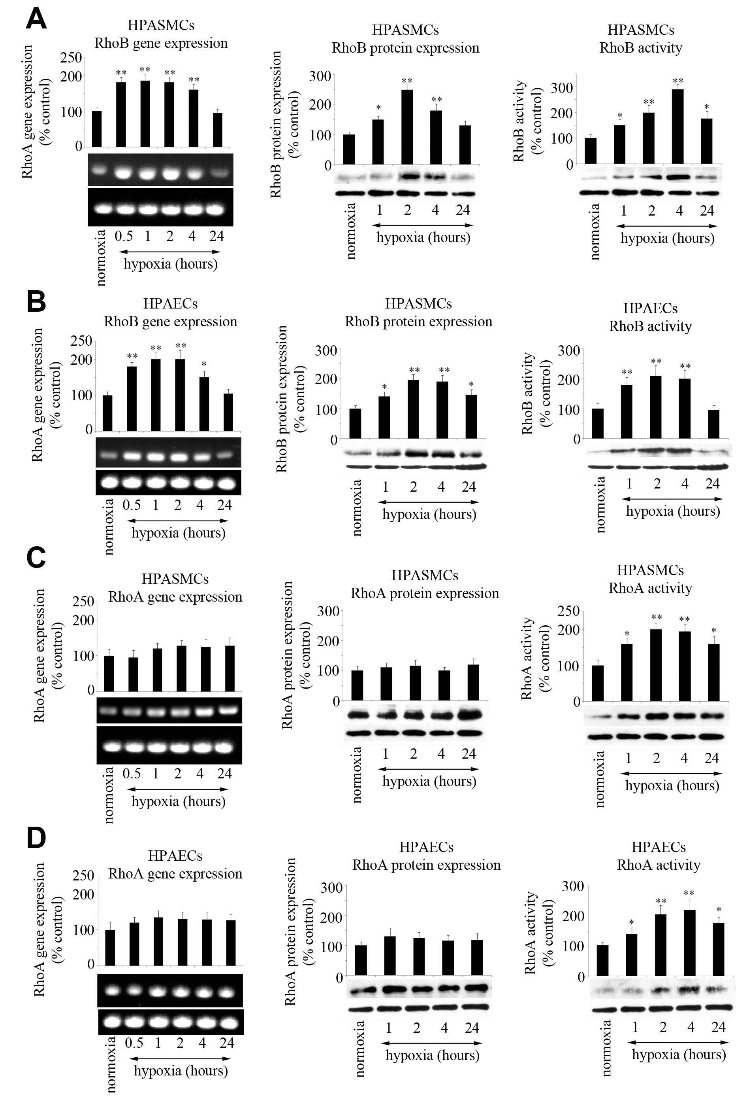
Figure 2. Confocal images of HPAECs (A) and HPASMCs (B) cultured in normoxic or hypoxic (1 hr) conditions and stained for F-actin and VE-cadherin, showing increased stress fibre formation under hypoxic conditions. Activated RhoB (AdCARhoB) mimics the effects of hypoxia, while inhibitory mutant of RhoB (AdDNRhoB) or manumycin (5 µmol/L) added 1h before the hypoxic exposure, inhibit the effects of hypoxia. Bar=10µm. Accompanying changes in endothelial permeability were measured using the Transwell assay (C). *P≤0.05, **P≤0.01, comparisons with normoxic control; ##P≤0.01, comparisons with hypoxic control, n=3.
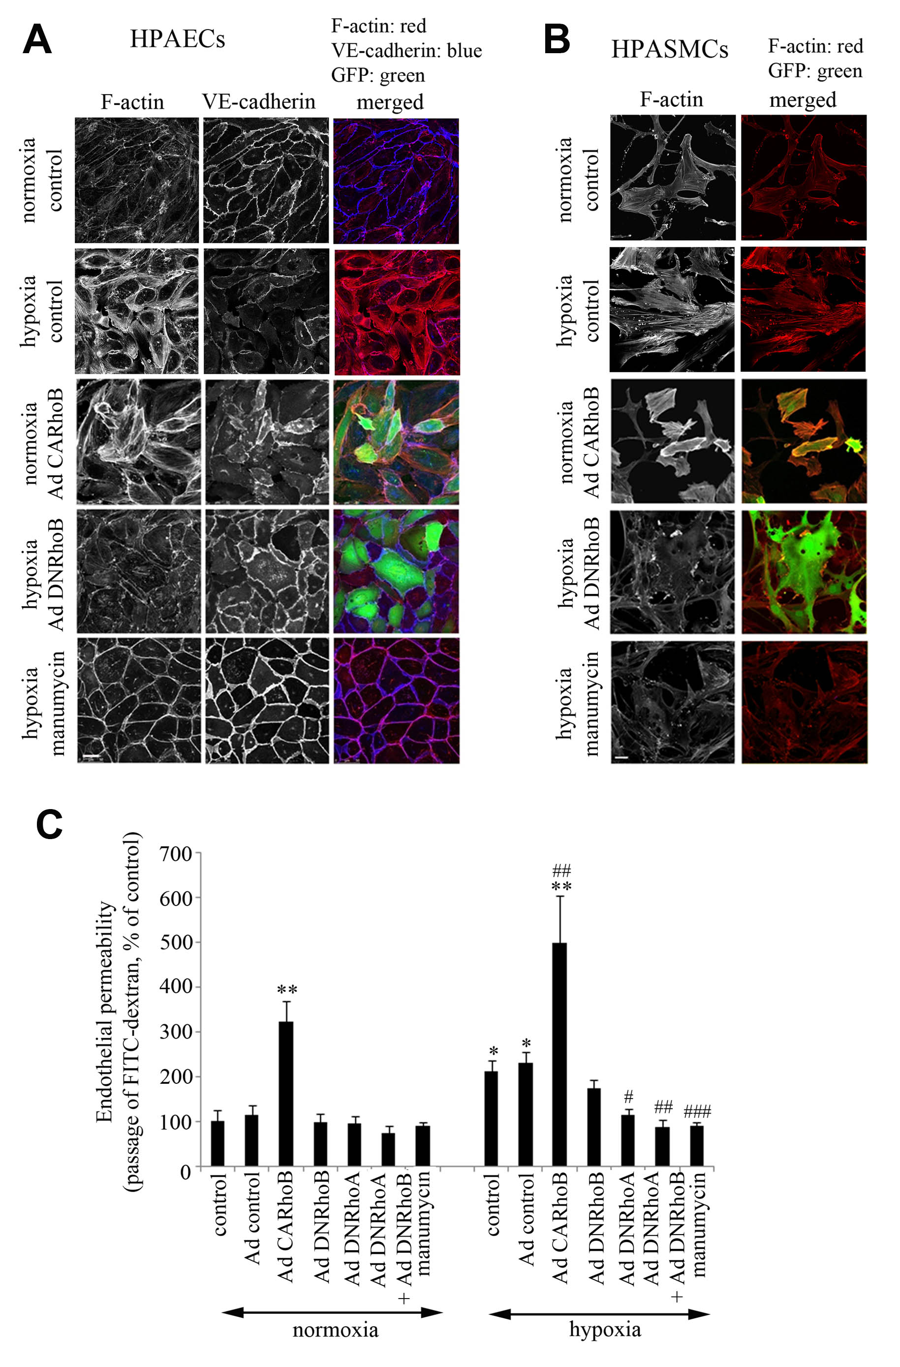

Figure 3. Hypoxia and RhoB increase myosin light chain (MLC) phosphorylation of Ser19. Time course of MLC phosphorylation in HPAECs (A) and HPASMCs (B), with representative examples of Western blots shown underneath the graphs. Changes in the levels MLC P-Ser19 in HPASMCs over expressing GFP (Ad control); CARhoB, DNRhoB or DNRhoA alone or in combination with DNRhoB; or treated with manumycin (5 µmol/L), as indicated (C). Manumycin was added to the cells 1 hr prior to hypoxic exposure and the cells were left in normoxia or in hypoxia for 2 hr. *P≤0.05, **P≤0.01, comparisons with normoxic control; #P≤0.05, ##P≤0.01, comparisons with hypoxic control n=4; (D) shows representative examples of Western blots corresponding to (C). In (B, C) n=4.
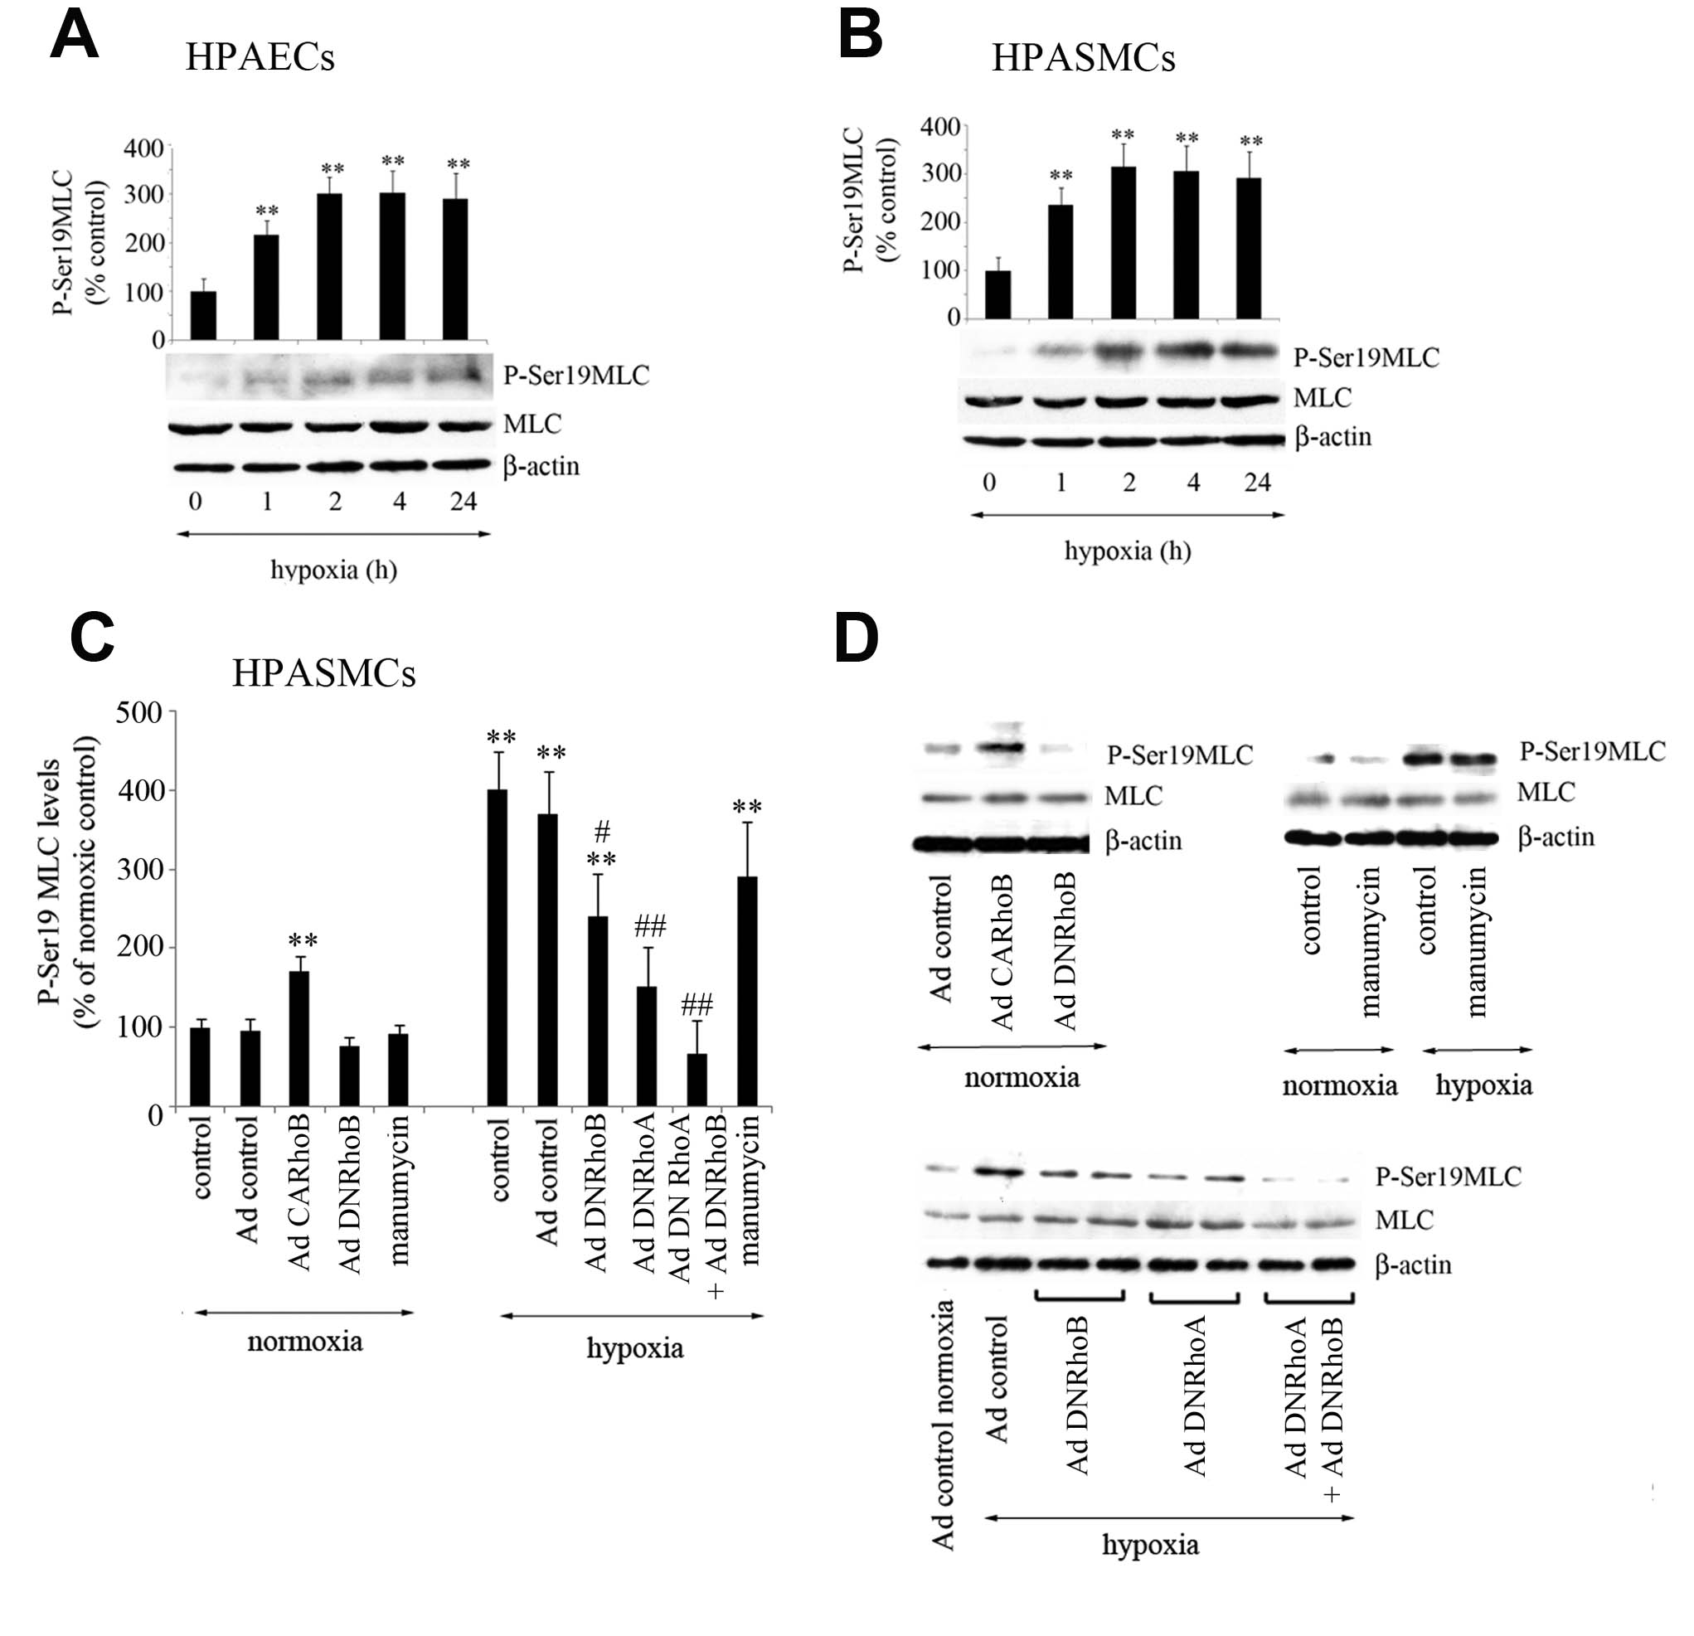

Figure 4. RhoB-induced morphological changes are inhibited by mDia1 siRNA or manumycin but not by Rho kinase inhibitor, Y-27632 (A). Western blot (B) of mDia1 protein expression in cells transfected with mDia1 siRNA. CARhoB over-expressing cells were transfected with mDia siRNA or were treated with manumycin (5 µmol/L, 2 hr) or Y-27632 (5 µmol/L, 6 hr) before cell fixation. F-actin is shown in the left panel, while the right panel shows cells over expressing GFP–V14RhoB. The arrow in the top left panel points to a contracting cell. Confocal microscopy; Bar=10 µm.
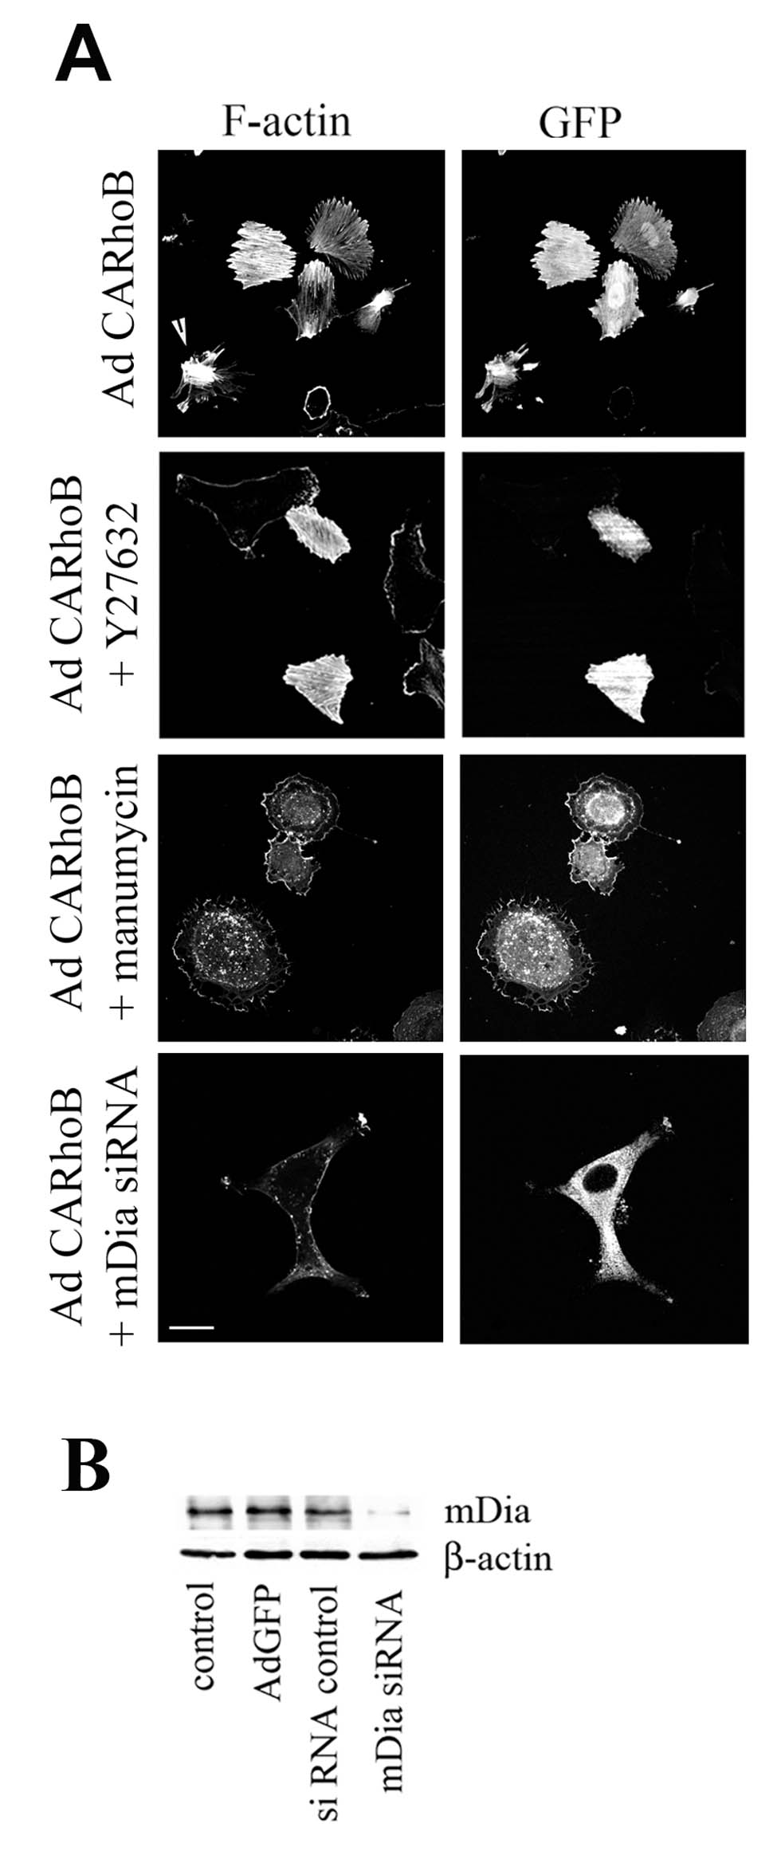

Figure 5. RhoB regulates hypoxia-induced growth responses in HPAECs (A) and HPASMCs (B). The cells over expressing Ad GFP (Ad control), AdCARhoB, AdDNRhoB, AdDNRhoA (alone or in combination with AdDNRhoB) were incubated in normoxia or in hypoxia for 48 hours, as indicated. Manumycin (5 µmol/L) was added at the start of hypoxic exposure. *P≤0.05, **P≤0.01, comparisons with normoxic control; #P≤0.05, ##P≤0.01, comparisons with hypoxic control, n=5

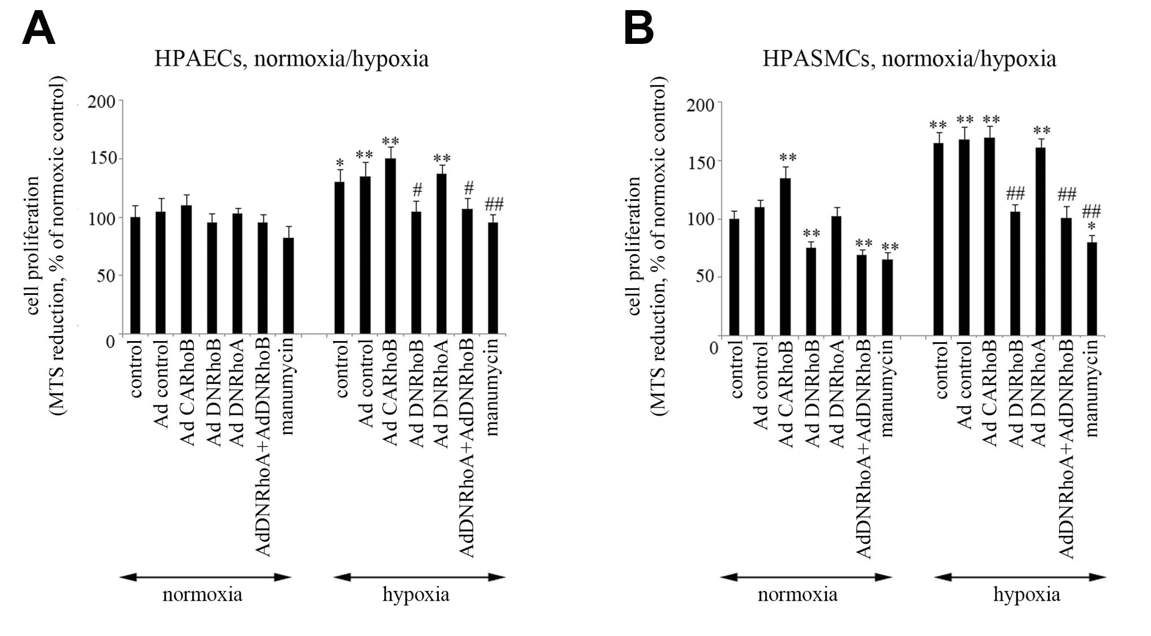

Figure 6. Effects of imatinib and RhoB on PDGF-stimulated (A, B) and hypoxia-induced (C, D) HPASMC proliferation and migration. MTS reduction was measured in cells expressing mutant Rho GTPases and incubated with PDGF-BB (20 µg/L) or exposed to hypoxia for 48 hr. Cell migration was studied 18 hr following treatment with PDGF or hypoxia. Manumycin (5 µmol/L) or imatinib (5 µmol /L) were added to the cells at the start of experiment. *P≤0.05, **P≤0.01, comparisons with normoxic/untreated control; #P≤0.05, ##P≤0.01, comparisons with hypoxic/PDGF-treated control, as appropriate. n=5

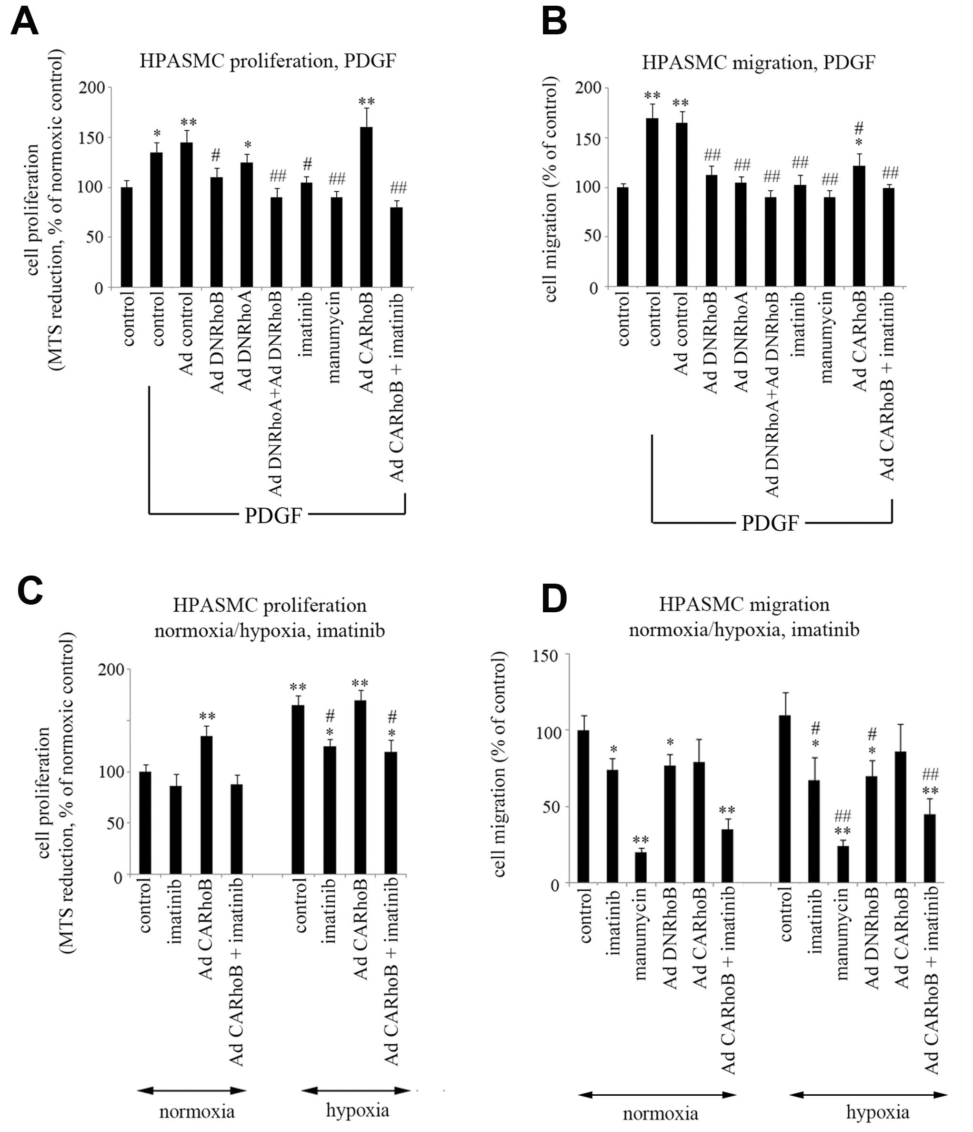

Figure 7. RhoB knockout attenuates development of chronic hypoxia-induced pulmonary hypertension.
Right ventricular systolic pressure (RVSP) (A, B) and right ventricular hypertrophy (RVH) (C) were measured in wild type controls (C57BL/6) mice and RhoB -/- mice following 2 week exposure to normoxia or hypoxia. **P≤0.01, ***P≤0.001, comparison with normoxic controls; #P≤0.05, ###P≤0.001, comparison with hypoxic controls; n=4-8. Representative RVSP polygraph tracings from the WT and RhoB-/- mice are shown (B). Percentage of muscularised vessels diameter ≤ 25 µm in lung sections (D) were reduced in RhoB-/- compared to wild type (WT) mice. *P≤0.05; ~500 vessels/lung section were scored in 4 WT and 4 RhoB-/- mice. Representative sections showing αSM actin staining in normoxic or the hypoxic wild type (WT) or RhoB-/- mice (E). The arrowheads in the middle panel point to the fully muscularised artery in hypoxic WT mice and partially muscularized artery in hypoxic RhoB -/- mice with magnified images shown in the right panel. Bar=10 µm.

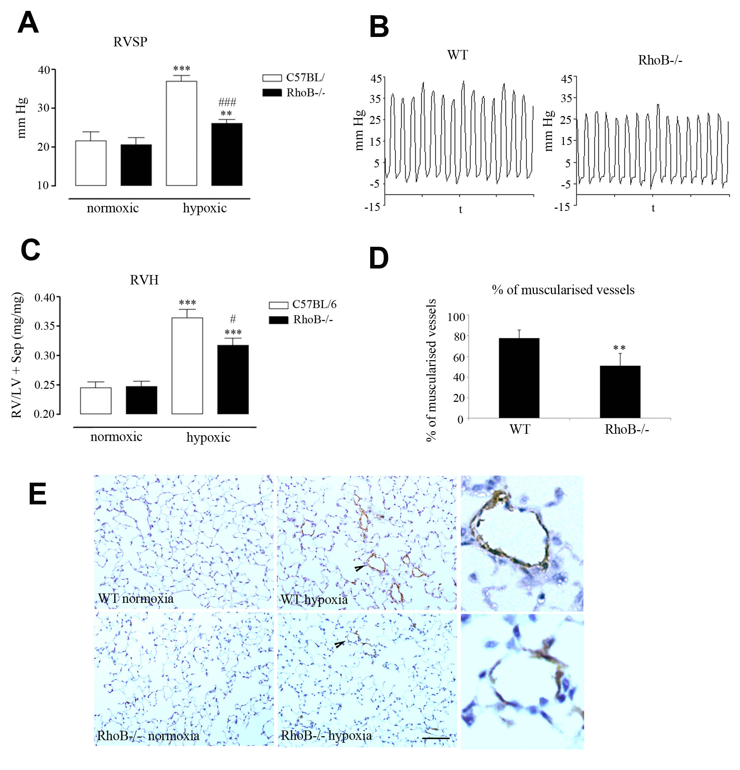

Figure 8. RhoB is required for HIF stabilisation in vitro and in vivo. (A) HIF activity in U2OS-HRE-luc cells measured by luciferase reporter assay following 24 hr exposure to hypoxia. (B) HIF1-α protein expression in HPAECs; (C, D) HIF1-α and PCNA protein expression in lungs from wild type (WT) and RhoB-/- mice, as indicated. (E) Inhibition of HIF1-α by DNRhoB but not DNRhoA in HPAECs by immunofluorescence and confocal microscopy; Bar=10 µm. (F) Representative examples of HIF1-α and PCNA protein expression, Western blotting. Cells and animals were treated as indicated; manumycin was added at the start of hypoxic exposure. Grey bars show normoxic HIF-1α levels, while black bars show hypoxic HIF-1α levels. n=4 (A, B) and n=4-6 (C, D); *P≤0.05; **P≤0.01, compared with hypoxic controls (A, B) or compared with hypoxic WT controls (C, D).
